**SUPPLEMENTARY MATERIAL**

**Homogenous Import Model**

Eqn S1.1

**Heterogenous Import Model**

Eqn S1.2

**Table S1. Description of compartments in homogenous and heterogeneous models.**

|  |  |  |
| --- | --- | --- |
| Compartment  Symbol | Compartment Description | Initial Condition |
| **SA** | Proportion of susceptible livestock | 0.98 |
| **ISA(D)1** | Proportion of livestock with antibiotic-sensitive *Salmonella* spp. carriage. (in domestic livestock in the heterogeneous model) | 0.01 |
| **IRA(D)1** | Proportion of livestock with antibiotic-resistant *Salmonella* spp. carriage. (in domestic livestock in the heterogeneous model) | 0.01 |
| **SH** | Proportion of susceptible humans | 1.00 |
| **ISH(D)1** | Proportion of humans infected with antibiotic-sensitive *Salmonella* spp. (from domestic sources in the heterogeneous model) | 0.00 |
| **IRH(D)1** | Proportion of humans infected with antibiotic-resistant *Salmonella* spp. (from domestic sources in the heterogeneous model) | 0.00 |
| **ISH(i)2** | Proportion of humans infected with antibiotic-sensitive *Salmonella* spp. from imported country *i* (only present in heterogeneous model). | 0.00 |
| **IRH(i)2** | Proportion of humans infected with antibiotic-resistant *Salmonella* spp. from imported country *i* (only present in heterogeneous model). | 0.00 |

1In the heterogeneous model, ISA and IRA parameters are changed into ISD and IRD to represent foodborne bacteria carriage in domestic (D) livestock.

2In the heterogeneous model, the human compartment are stratified to track the proportion of human antibiotic-sensitive/resistant infections from each importing country. e.g: The proportion of antibiotic-sensitive human foodborne infection from importing country is: .

**DATASETS AND DATA MANIPULATION**

We note the use of three curated datasets for this study. These datasets were used for three purposes: 1) Fitting the relationship between domestic livestock ampicillin usage and resistance, 2) Parameterising the relative share of import, contamination and resistance among importing countries and 3) UK-specific outcome measures for the *Salmonella* spp. in fattening pigs case study.

1. **Relationship between domestic ampicillin usage/resistance dataset**

Ampicillin sales data from the European Surveillance of Veterinary Antimicrobial Consumption (ESVAC) from 2015-2018 was used in this study as a proxy for antibiotic usage (1-4). The rationale for the use of antibiotic sales data as a proxy for usage and details of scaling calculations used to scale general sales data for fattening pig biomass can be found in the **supplementary material** for chapter 2.

The unit of measurement used for the ESVAC dataset was gram per population correctional unit (g/PCU). Yearly ESVAC sales data was paired with data on the proportion of ampicillin-resistant isolates from fattening pig carcasses for different EU countries across 2015-2018 extracted from European Food Safety Authority (EFSA) summary reports (5-8). An exploratory linear regression was conducted to identify evidence of a relationship between ampicillin usage and resistance (Figure S1).

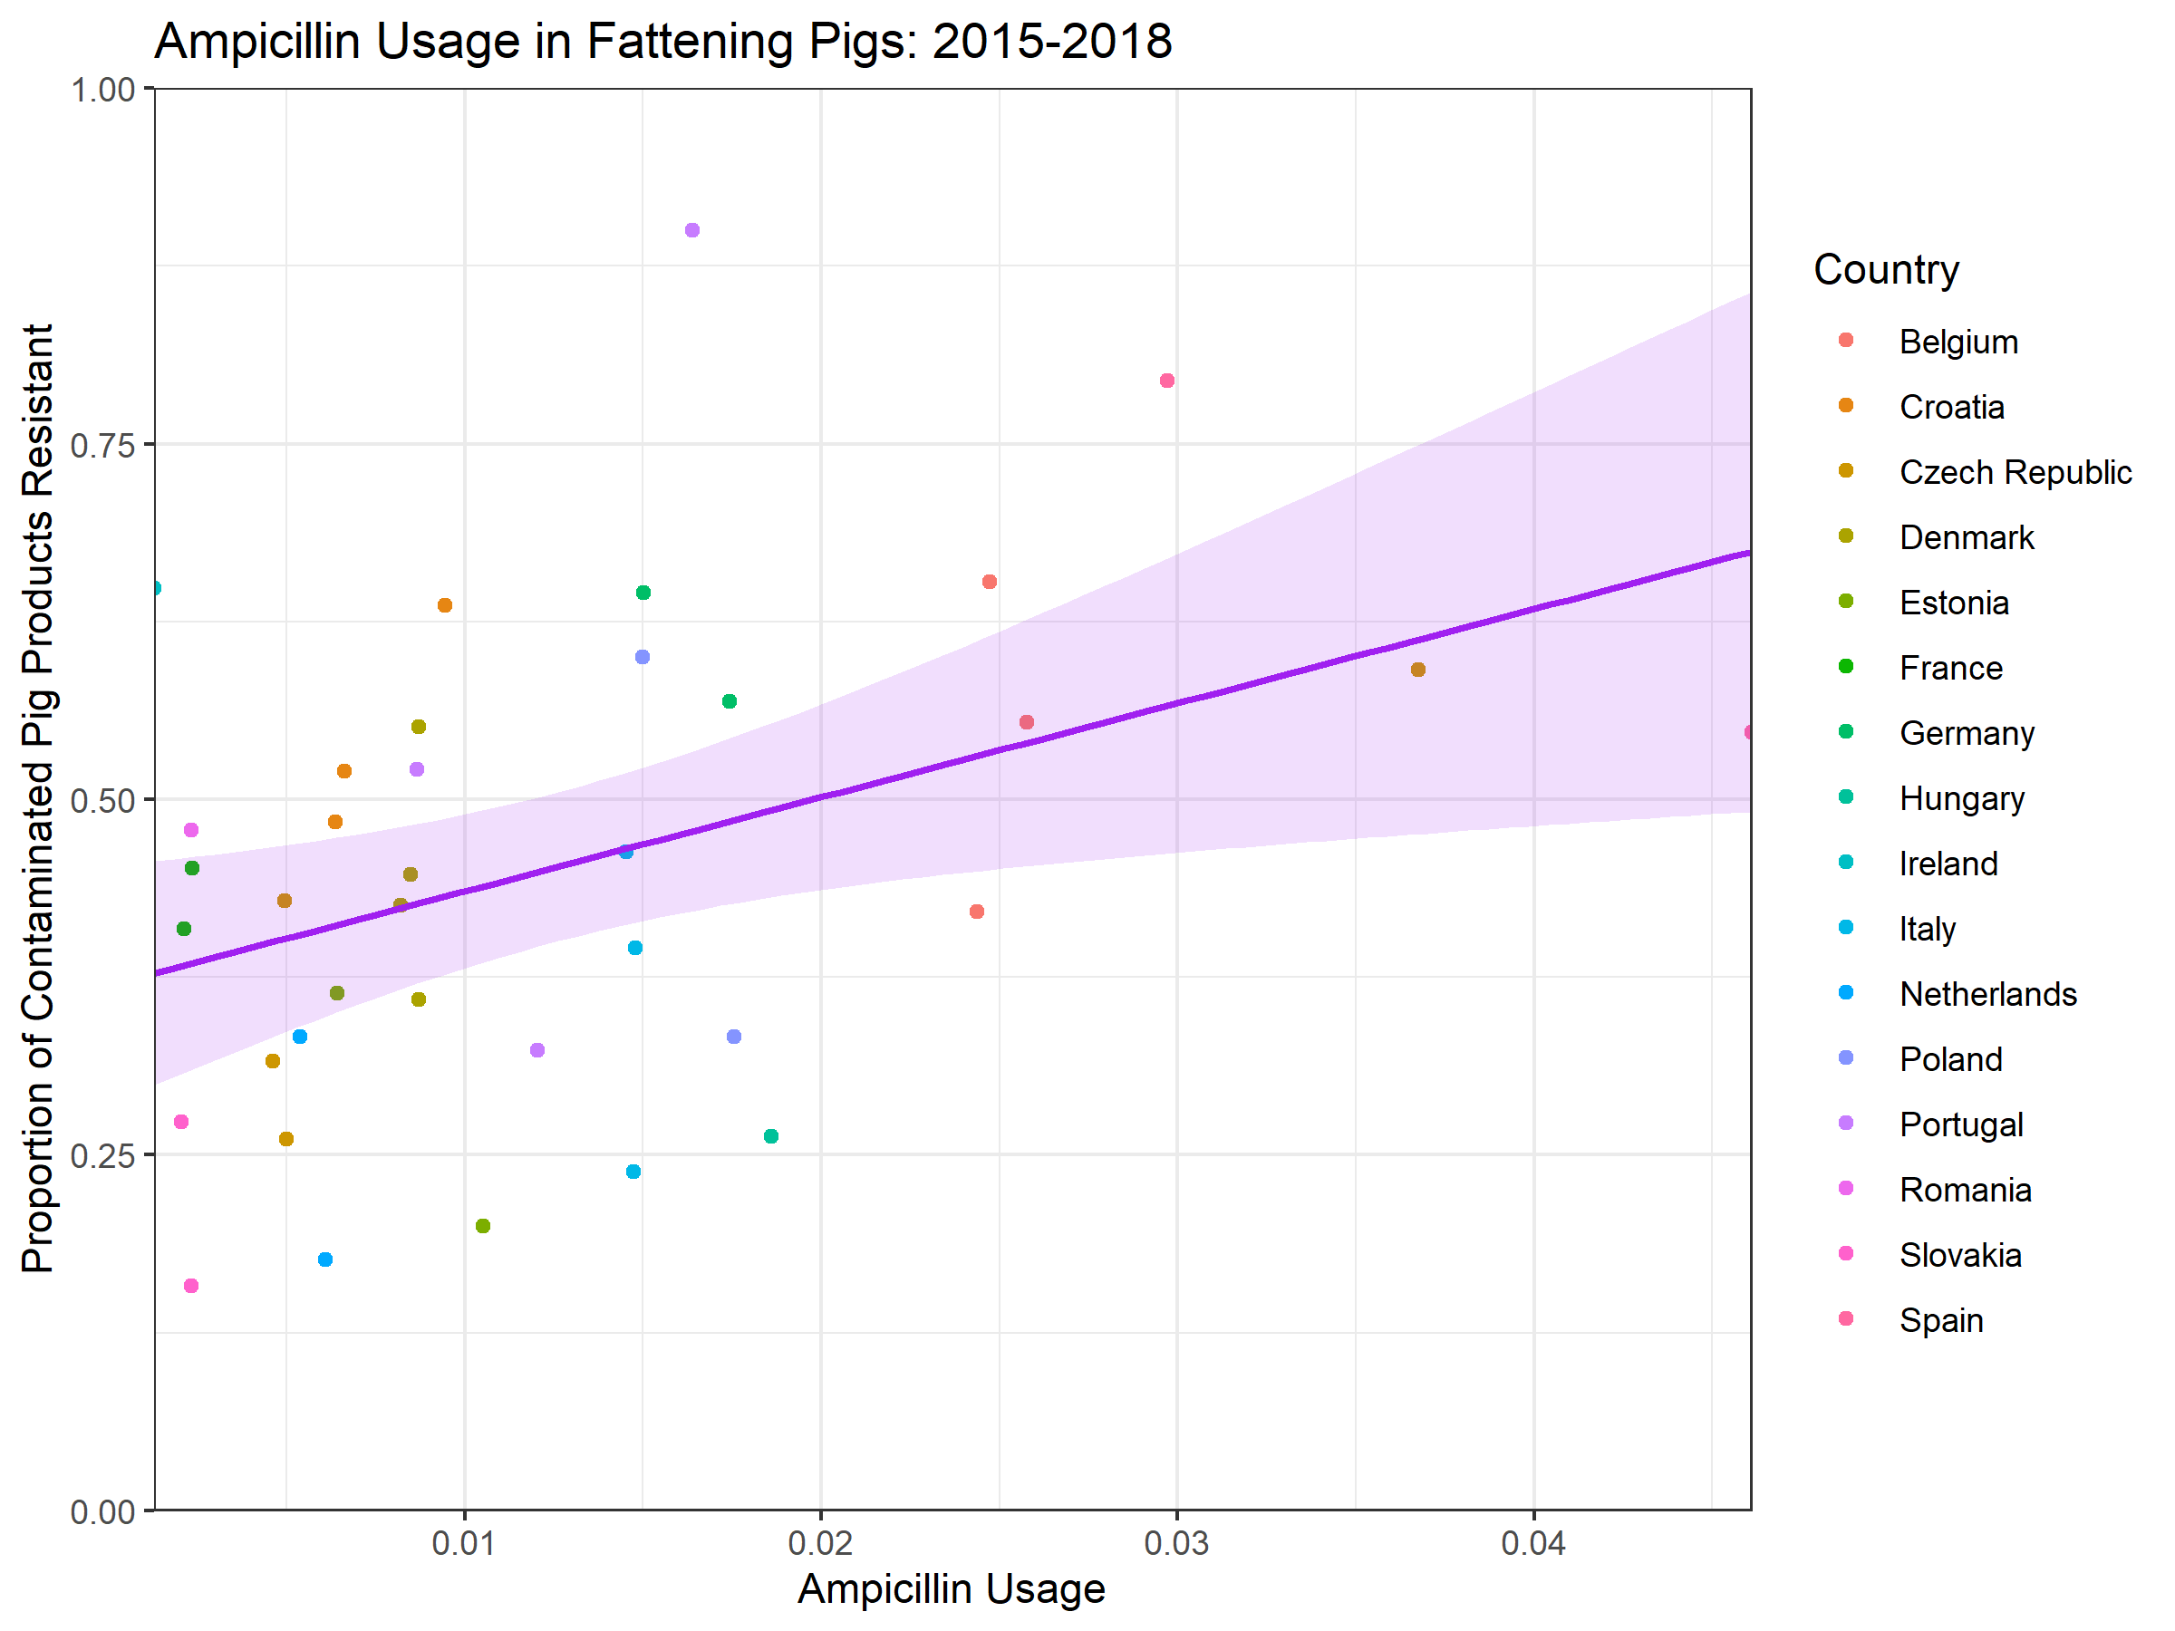

**Figure S1. Relationship between scaled ampicillin sales and the proportion of isolates ampicillin-resistant across different EU country/year pairs from 2015-2018.** Solid line and ribbon represent the best fitting linear regression between sales and resistance, with 95% CIs for model predictions. Variables: Intercept constant = 0.369, Effect of ampicillin usage (g/PCU) = 6.661.

As a key aim of the model was to assess the AMR dynamics following a withdrawal in livestock antibiotic usage, it is critical that the model was able to reproduce the relationship between livestock antibiotic usage and resistance. Therefore, the livestock portion of the model was fitted to the relationship between ampicillin usage and resistance using the paired ESVAC/EFSA surveillance data. A sum of square differences distance measure was used in the approximate Bayesian computation sequential Monte Carlo model fitting approach to fit the model output to the data.

1. **Parameterising import-relevant parameters**

Parameterisation for import-relevant parameters (FracImp, PropResImp, Weight, ψ) was necessary for both the homogenous (averaged) and heterogeneous (stratified) model. Department for Environment, Food & Rural Affairs (DEFRA) data was used to identify the relative share of domestic, European Union and non-EU countries in contributing the United Kingdom’s livestock food product supply (9) (Table S2). This data was available for cattle/calves, pig meat, lamb/mutton, poultry meat and eggs. Data on milk was ignored due to the inability to standardise units to match other livestock food products.

**Table S2. Proportion of the UK food supply for different livestock food products attributable to domestic, EU and non-EU sources.**

|  |  |  |  |  |  |  |  |
| --- | --- | --- | --- | --- | --- | --- | --- |
| Livestock Species | Domestic Food Production | EU Food Production | Non-EU Food Production | Total UK Production | Proportion of UK Food Supply from | | |
| **Domestic** | **EU** | **Non-EU** |
| **Cattle and Calves** | 761 | 343 | 22 | 1126 | **0.676** | **0.305** | **0.0195** |
| **Pig Meat** | 637 | 792 | 1 | 1430 | **0.446** | **0.554** | **0.000699** |
| **Lamb and Mutton** | 203 | 21 | 76 | 300 | **0.677** | **0.07** | **0.2533** |
| **Poultry Meat** | 1487 | 549 | 36 | 2072 | **0.718** | **0.265** | **0.0174** |
| **Eggs** | 633 | 108 | 0.685 | 741 | **0.854** | **0.145** | **0.000924** |
| **Total** | 3721 | 1813 | 136 | 5669 | **0.656** | **0.320** | **0.0239** |

The proportion of UK food produce from EU sources was also stratified further into separate EU countries. The primary countries that contribute to the UK food supply was identified through DEFRA data with regards to millions of pounds (£ million) spent by the UK on food imports from each country. EU countries in this list were normalised and anonymised and used to generate the % of total imports attributable to each EU country (9) (Table S3).

**Table S3. Imports of food products by the country of dispatch (with EU countries anonymised) for the United Kingdom**

|  |  |  |
| --- | --- | --- |
| EU Country | £ (Millions) | % of total EU imports |
|
| **Country 1** | 5518 | 17.65 |
| **Country 2** | 4557 | 14.58 |
| **Country 3** | 4555 | 14.57 |
| **Country 4** | 4522 | 14.47 |
| **Country 5** | 3497 | 11.19 |
| **Country 6** | 2964 | 9.48 |
| **Country 7** | 2554 | 8.17 |
| **Country 8** | 1845 | 5.9 |
| **Country 9** | 1249 | 3.99 |

Stratified data on the extent of UK food product import from different EU countries (Table S2) was combined with data on the relative share of domestic/EU/nEU countries for general livestock food products (total) and pig meat (Table S3). These rescaled proportions were used to parameterise the relative proportion of the UK food supply from domestic, EU trade partners and non-EU sources for two different case studies – general livestock food products (Table S4) and pig meat products (Table S5).

**Table S4. Final proportion of UK food supply attributable to domestic, EU importing countries and non-EU sources for general livestock food products.**

|  |  |  |
| --- | --- | --- |
| Country | Overall Share of Import (general) | Scaled Import Contribution  (Share Parameter) |
| **UK (Domestic)** | 0.656 | 0 |
| **Country 1** | 0.056485883 | 0.1642031 |
| **Country 2** | 0.046648517 | 0.1356062 |
| **Country 3** | 0.046629713 | 0.1355515 |
| **Country 4** | 0.046289683 | 0.134563 |
| **Country 5** | 0.035796287 | 0.104059 |
| **Country 6** | 0.03033596 | 0.08818593 |
| **Country 7** | 0.026145388 | 0.07600404 |
| **Country 8** | 0.018882142 | 0.05488995 |
| **Country 9** | 0.012786427 | 0.03716985 |
| **Country nEU** | 0.024 | 0.06976743 |

**Table S4. Final proportion of UK food supply attributable to domestic, EU importing countries and non-EU sources for fattening pig food products.**

|  |  |  |
| --- | --- | --- |
| Country | Overall Share of Import (general) | Scaled Import Contribution  (Share Parameter) |
| **UK (Domestic)** | 0.445 | 0 |
| **Country 1** | 0.0981 | 0.176756757 |
| **Country 2** | 0.0808 | 0.145585586 |
| **Country 3** | 0.0807 | 0.145405405 |
| **Country 4** | 0.0802 | 0.144504505 |
| **Country 5** | 0.0619 | 0.111531532 |
| **Country 6** | 0.0525 | 0.094594595 |
| **Country 7** | 0.0453 | 0.081621622 |
| **Country 8** | 0.0327 | 0.058918919 |
| **Country 9** | 0.0222 | 0.04 |
| **Country nEU** | 0.0006 | 0.001081079 |

Data was then sought on the extent of *Salmonella* spp. contamination and the proportion of ampicillin-resistant *Salmonella* spp. isolates obtained from fattening pig carcasses (Table S5). This data was obtained from European Food Safety Authority (EFSA) and European Centers for Disease Prevention and Control (ECDC) summary reports for zoonoses/foodborne outbreaks and antimicrobial resistance in livestock (5-8, 10-13). Data was prioritised from competent authorities (CA) and 400cm2 carcass swabs where possible, to standardise parameterisation for the modelled importing countries.

**Table S5. Parameterisation for the extent of *Salmonella* spp. contamination and ampicillin-resistance for fattening pig carcasses in UK, EU importing countries and non-EU countries.**

|  |  |  |
| --- | --- | --- |
| Country | Proportion Contaminated | Proportion Ampicillin-Resistance |
| **UK (Domestic)** | 0.02865329 | 0.4166667 |
| **Country 1** | 0.08512036 | 0.2549020 |
| **Country 2** | 0.04699739 | 0.6481481 |
| **Country 3** | 0.03289161 | 0.6068944 |
| **Country 4** | 0.10757448 | 0.4300760 |
| **Country 5** | 0.17013733 | 0.6706597 |
| **Country 6** | 0.04037436 | 0.3166283 |
| **Country 7** | 0.05837409 | 0.5427247 |
| **Country 8** | 0.01205000 | 0.4666667 |
| **Country 9** | 0.01152677 | 0.4455724 |
| **Country nEU** | **Fitted** (For the heterogeneous model) | **Fitted** (For the heterogeneous model) |

1. **UK-specific Outcome Measure dataset**

Data for four UK-specific outcome measures were sought for approximate Bayesian computation sequential Monte Carlo targets for model fitting. These outcome measures were the observed ECDC daily EU incidence of human salmonellosis, which was used as a proxy for the baseline incidence of UK salmonellosis (0.593 per 100,000) (14). This proxy was chosen due to the lack of multiplication factors available to scale UK-specific reported incidence of salmonellosis to community levels (14).

The proportion of ampicillin-resistant UK human salmonellosis was obtained from 2015-2018 ECDC AMR summary reports (0.207) (10-13). The proportion of ampicillin-resistant UK livestock Salmonella spp. carriage was parameterised from 2015-2018 EFSA surveillance reports (0.417) (5-8). It is important to note that one data point was not used (2016), with this data point suggestion 100% ampicillin-resistance in fattening pig carcasses for the UK (45/45). This data point was as stark outlier compared to the other data points and was therefore omitted to prevent unfair influence on the average ampicillin resistance. The proportion of contamination in UK swine carcasses was calculated from 2015-2018 ECDC one health surveillance reports (0.0628) (10-13). The baseline UK ampicillin usage/sales for the ampicillin-resistance in fattening pigs case study was considered the unweighted average ampicillin usage observed across 2015-2018 for the UK (τ = 0.0009 g/PCU) (1-4).

**SUPPLEMENTARY TABLES**

**Table S6. Prior distributions used for ABC-SMC model fitting**

|  |  |  |  |  |  |  |  |  |  |
| --- | --- | --- | --- | --- | --- | --- | --- | --- | --- |
| Summary Statistics | Model | Generation | | | | | | | |
| **1** | **2** | **3** | **4** | **5** | **6** | **7** | **8** |
| **Sum of squared errors** | Homogenous Import Model | 5 | 4 | 3.5 | 3 | 2.5 | 2.25 | 2 | 1.8 |
| Heterogeneous Import Model1 | 5 | 4.5 | 4 | 3.5 | 3.25 | 3 | 2.75 | 2.5 |
| **Difference between modelled and observed overall prevalence of human salmonellosis** | Homogenous Import Model | 0.593 | 0.474 | 0.356 | 0.237 | 0.178 | 0.148 | 0.119 | 0.104 |
| Heterogeneous Import Model1 | 0.593 | 0.474 | 0.356 | 0.297 | 0.237 | 0.178 | 0.148 | 0.119 |
| **Difference between modelled and observed proportion of resistant human salmonellosis** | Homogenous Import Model | 0.208 | 0.166 | 0.125 | 0.083 | 0.062 | 0.0519 | 0.0415 | 0.036 |
| Heterogeneous Import Model1 | 0.208 | 0.166 | 0.125 | 0.104 | 0.083 | 0.062 | 0.0519 | 0.0415 |
| **Difference between modelled and observed level of domestic carcass contamination** | Homogenous Import Model | 0.0287 | 0.023 | 0.017 | 0.012 | 0.009 | 0.0072 | 0.006 | 0.005 |
| Heterogeneous Import Model1 | 0.0287 | 0.0229 | 0.0172 | 0.0143 | 0.0115 | 0.0086 | 0.0072 | 0.0057 |
| **Difference between modelled and observed proportion of ampicillin-resistant isolates on domestic carcasses** | Homogenous Import Model | 0.4167 | 0.333 | 0.250 | 0.167 | 0.125 | 0.1042 | 0.083 | 0.073 |
| Heterogeneous Import Model1 | 0.4167 | 0.333 | 0.250 | 0.208 | 0.1667 | 0.125 | 0.104 | 0.083 |

1Note that differences in ε thresholds were due to difficulties fitting the heterogeneous import model to the same thresholds as the homogenous import model. Therefore, thresholds were loosened.

**Table S7. Fitted values for the primaryoutcome measures for the four modelcase studies.**

|  |  |  |
| --- | --- | --- |
| Outcome Measure | Model | |
| **Homogenous Import Model** | **Heterogeneous Import Model** |
| **Daily incidence of human salmonellosis (per 100,000)** | 0.586 | 0.597 |
| **Proportion of antibiotic-resistant human salmonellosis** | 0.242 | 0.240 |
| **Proportion of domestic fattening pig carcasses contaminated with Salmonella spp.** | 0.031 | 0.030 |
| **Proportion of contaminated fattening pig carcasses resistant to ampicillin** | 0.345 | 0.339 |

**Table S8. Parameter values for case studies and fitted parameters.**

|  |  |  |  |  |
| --- | --- | --- | --- | --- |
| Parameter | Description | Model (Fitted) Parameter Values  (Sum of squares from model fit in square brackets) | | References |
| **Homogenous Import Model**  **(SS = 1.718)** | **Heterogeneous Import Model**  **(SS = 2.193)** |
| ***βAA*** | Per Capita Rate of Transmission (Direct and Indirect) between the Infected Domestic Animal Fraction and Domestic Susceptible Animal Fraction | **0.00069**  **[0.000011,**  **0.00182] 1** | **0.0022536**  **[0.00002217,**  **0.005455] 1** | N/A |
| ***βHA*** | Per Capita Rate of Transmission (Direct and Indirect) from the Domestic Infected Animal Carcasses to the Susceptible Human Fraction | **0.00408**  **[0.00330,**  **0.00480] 1** | **0.004127**  **[0.**00**2042,**  **0.0050212] 1** | N/A |
| ***ζ*** | Background rate of transmission of foodborne bacteria to the livestock population | **0.011712 [0.0010,**  **0.01313] 1** | **0.011280**  **[0.00849,**  **0.014329] 1** | N/A |
| ***τ*** | Per Capita Rate of Antibiotic Usage in Livestock (Baseline) in g/PCU | 0.0067 | 0.0067 | N/A |
| *κ* | Efficacy of antibiotic-mediated livestock recovery. | **1.6211 [1.15162,**  **2.0271] 1** | **3.52946**  **[1.230218,**  **5.377325] 1** | N/A |
| ***α*** | Transmission-related fitness costs associated with antibiotic-resistant strains (relative to antibiotic-sensitive strains). | **0.5565 [0.5389,**  **0.59943] 1** | **0.566287**  **[0.011241,**  **0.317247] 1** | N/A |
| ***φ*** | Per Capita Rate of Conversion from antibiotic-resistant to antibiotic-sensitive infection in animals | **0.000194**  **[0.00008,**  **0.000512] 1** | **0.000995**  **[0.000036,**  **0.0024204] 1** | N/A |
| ***rA*** | Per Capita Rate of Natural Recovery from Animal Infection | 60 days-1 | 60 days-1 | (15) |
| ***rH*** | Per Capita Rate of Natural Recovery from Human Infection | 5.5 days-1 | 5.5 days-1 | (16) |
| ***µA*** | Per Capita Birth/Death Rate in Animals | 240 days-1 | 240 days-1 | (17) |
| ***µH*** | Per Capita Birth/Death Rate in Humans | 28835 days-1 | 28835 days-1 | (18) |
| ***η*** | Relative reduction in foodborne bacteria prevalence from domestic livestock carriage to contamination on carcasses | 0.1102 | 0.1102 | (19) |
| ***ψ*** | Proportion of UK food supply from domestic sources | 0.656 and 0.4455 | 0.656 and 0.4455 | (9) |
| ***FracImpnEU*** | Proportion of contaminated food imports with *Salmonella* spp. | - | **0.1455506236 [0.002163,**  **0.280768] 1** | N/A |
| ***PropResImpnEU*** | Proportion of food imports contaminated with antibiotic-sensitive bacteria | - | **0.4646441629**  **[0.0273738,**  **0.941223] 1** | N/A |

1Note that values in bold are meanpoint estimates from the posterior distribution of fitted parameters, lower and upper bounds of the 95% HDI are shown in square brackets.

**SUPPLEMENTARY FIGURES**

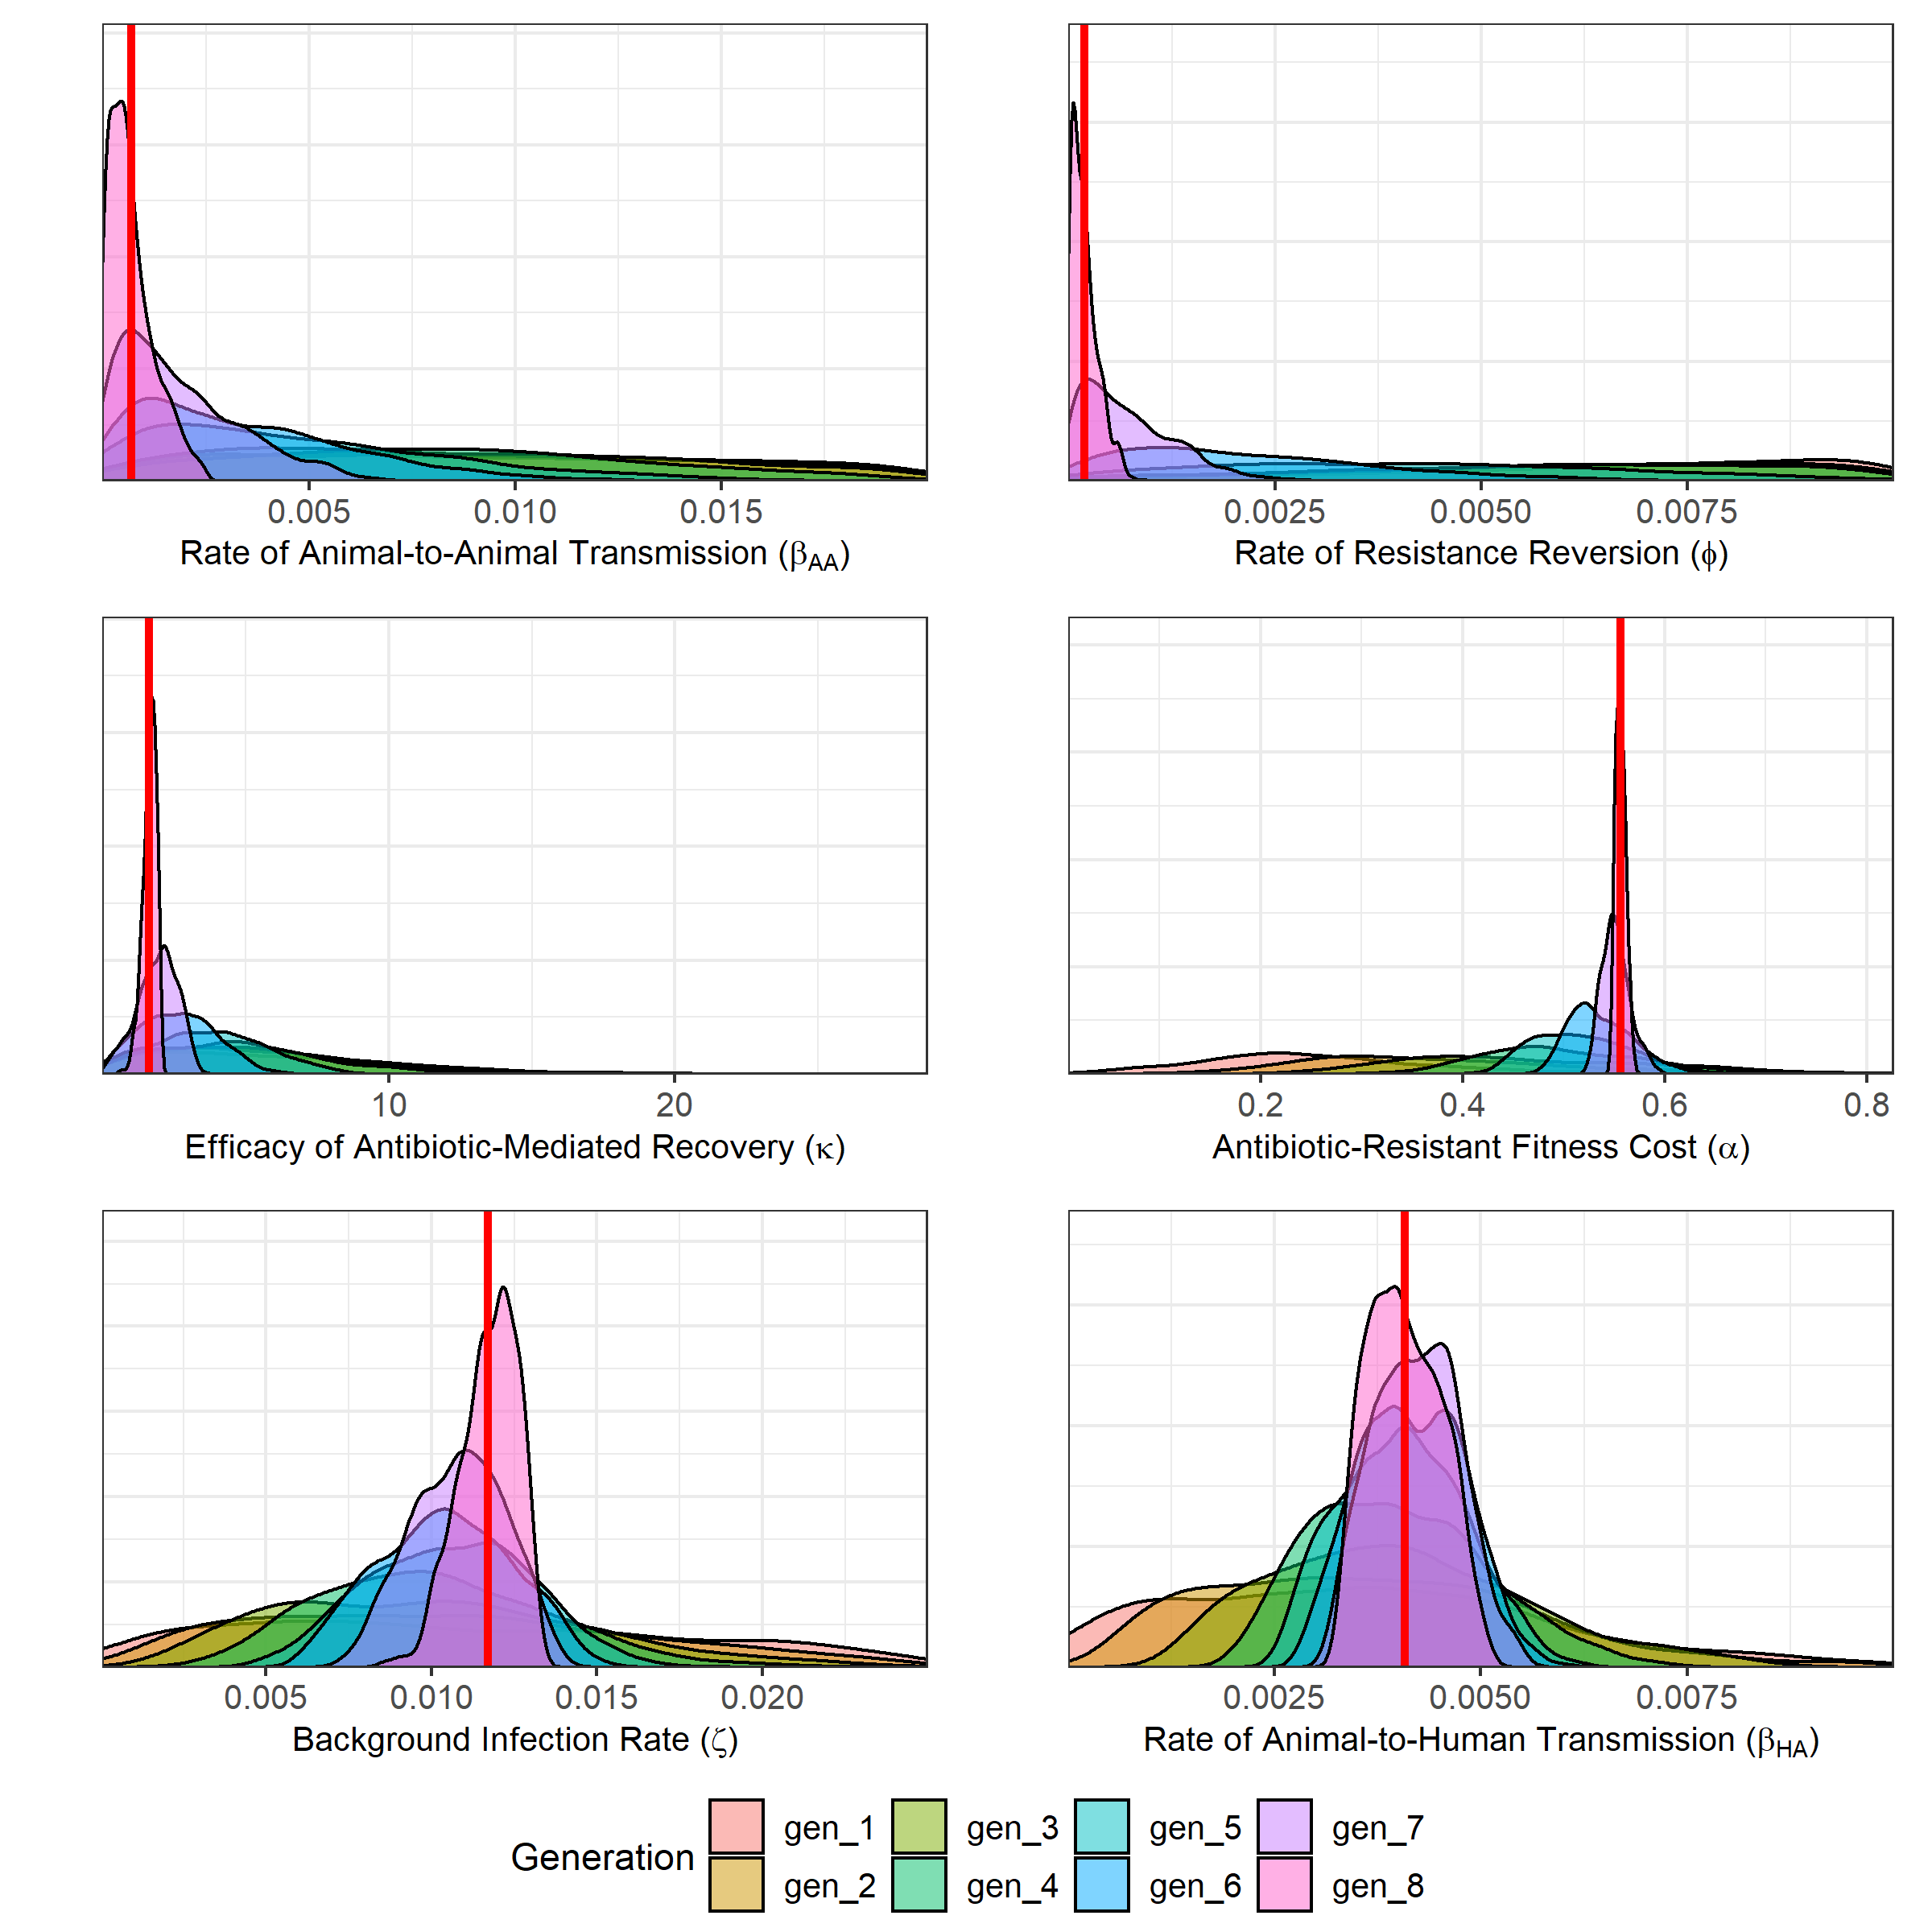

**Figure S2. Estimated posterior distributions for the rate of animal-to-animal transmission (βAA), efficacy of antibiotic-mediated recovery (κ), rate of antibiotic-resistant to antibiotic-sensitive reversion (φ), transmission-related fitness costs of resistance (α), background rate of transmission to animal populations (ζ) and the rate of animal-to-human transmission (βHA).** The estimated posterior distribution for each generation is highlighted by fill colours. Red line represents the mean from the 8th generation for each parameter.

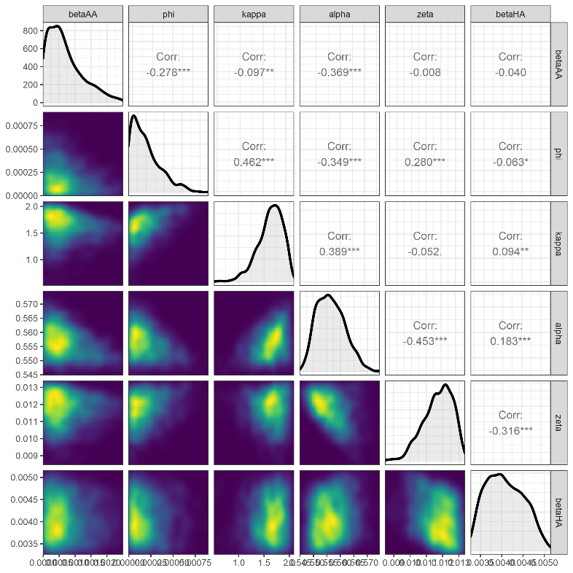

**Figure S3. Pairs plot for the approximated posterior distribution and the correlation coefficients for the homogenous import model fit.** The diagonals show the the approximated univariate posterior distribution. Kernel density estimation was used to identify the parameter space where a greater concentration of particles were accepted for the final tenth ABC-SMC generation (lighter colouring).

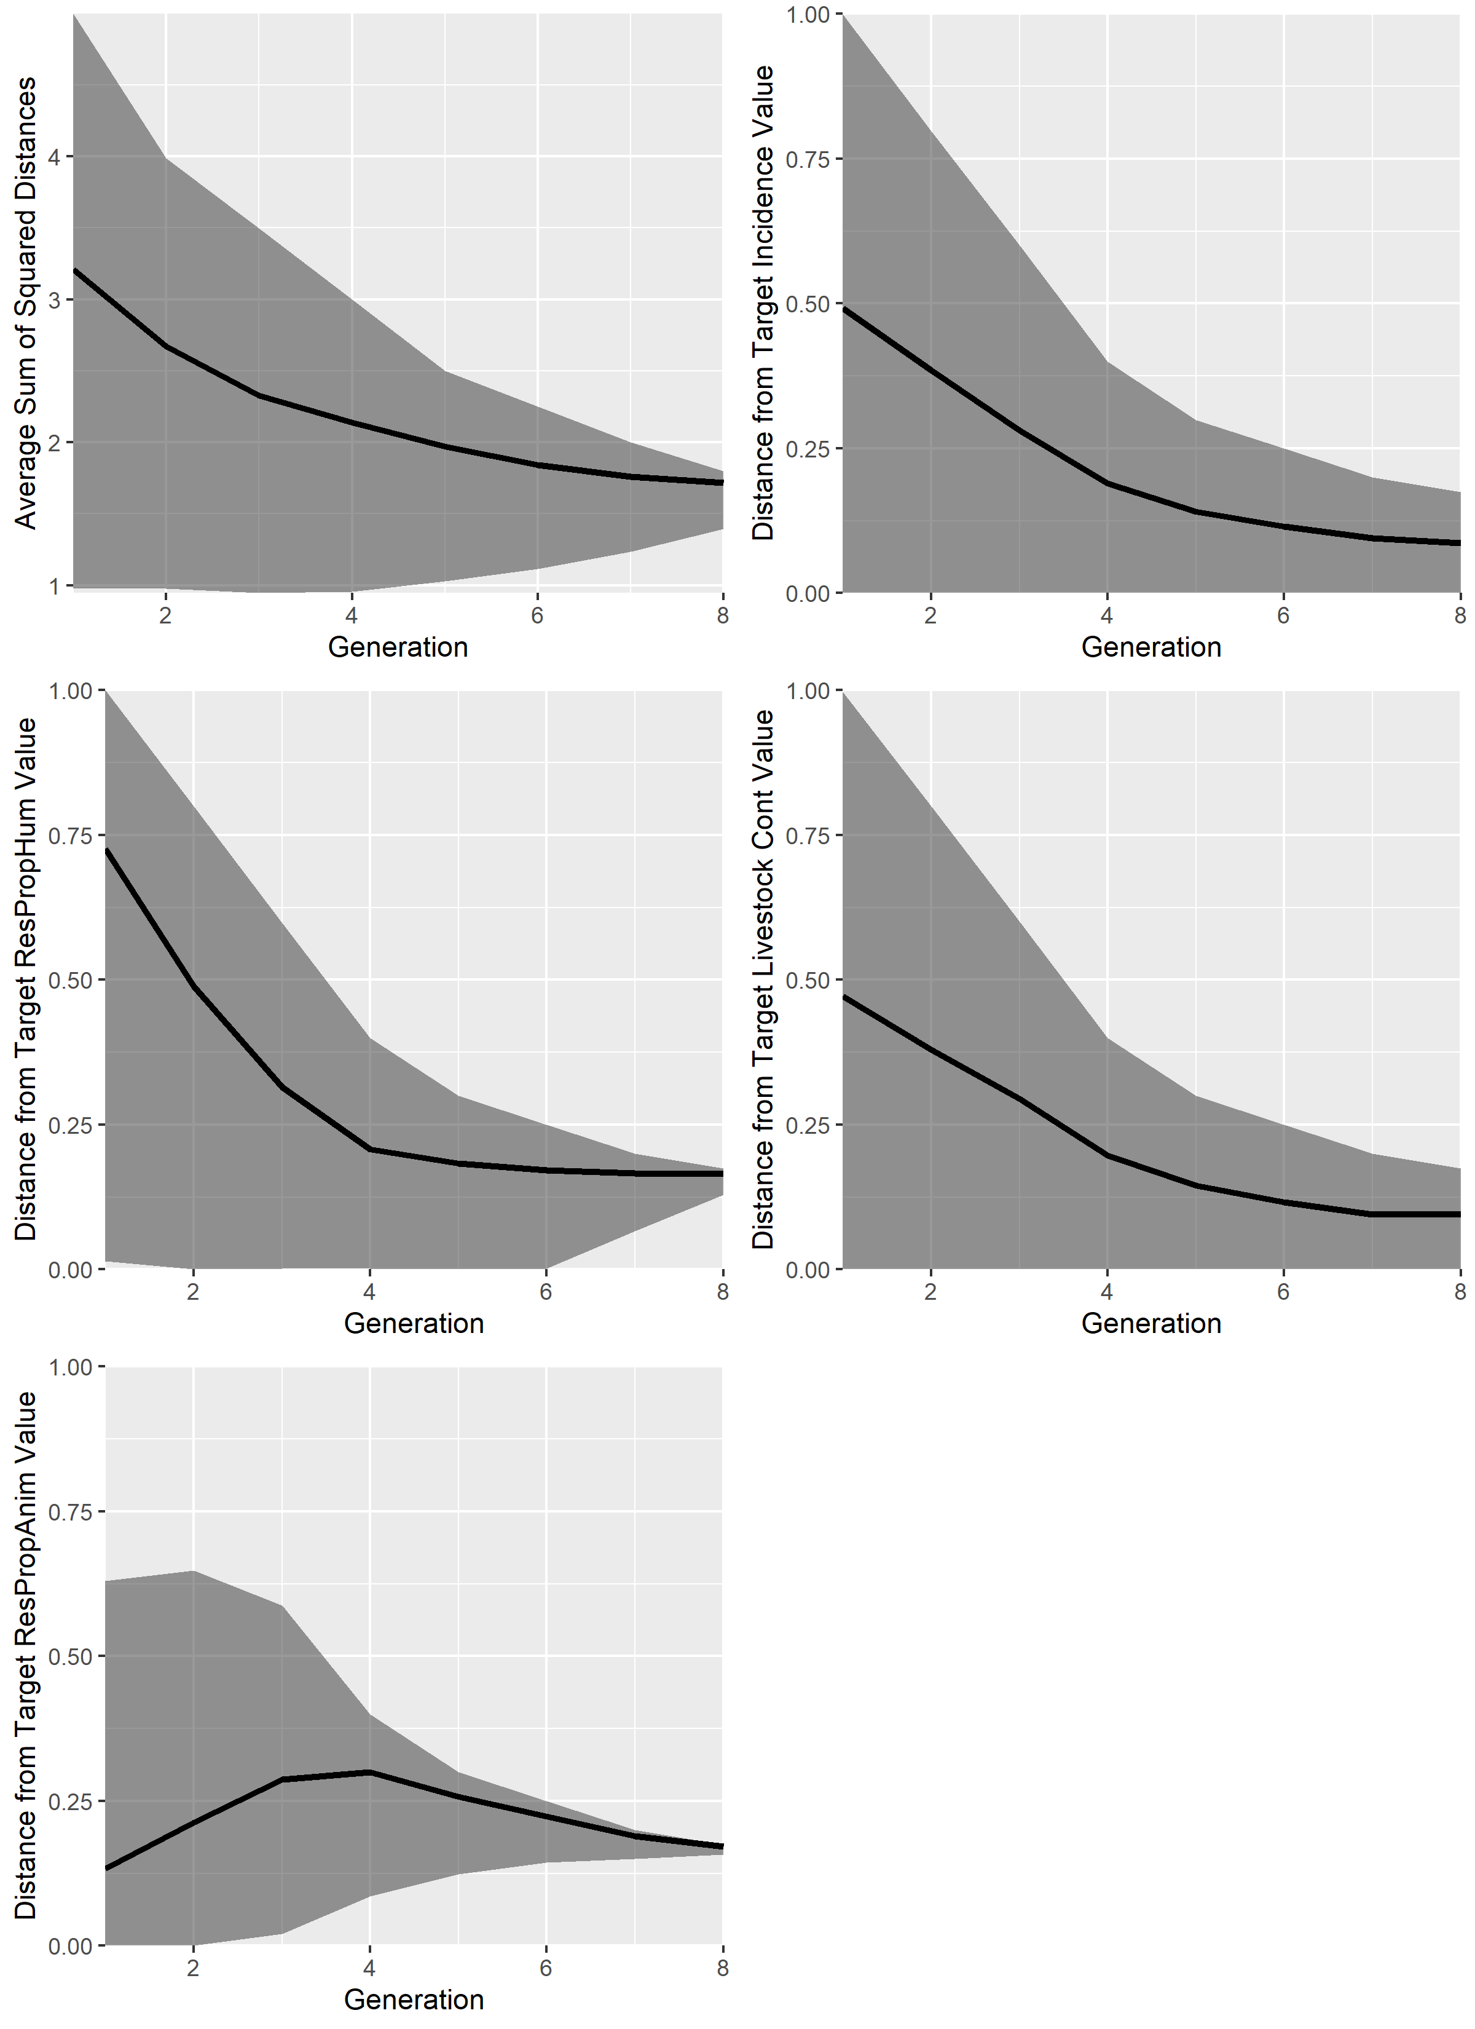

**Figure S4. Diagnostic plots showing the average sum of squared distance for each generation of the ABC-SMC model fit for the homogenous model.** Diagnostic plots were plotted for the average sum of square distances for the resistance/usage model fit, distance from the target incidence of human salmonellosis, distance from the target proportion of resistant human salmonellosis, distance from the target livestock contamination (ISA + IRA * η) and the distance from the target proportion of antibiotic-resistant human salmonellosis.

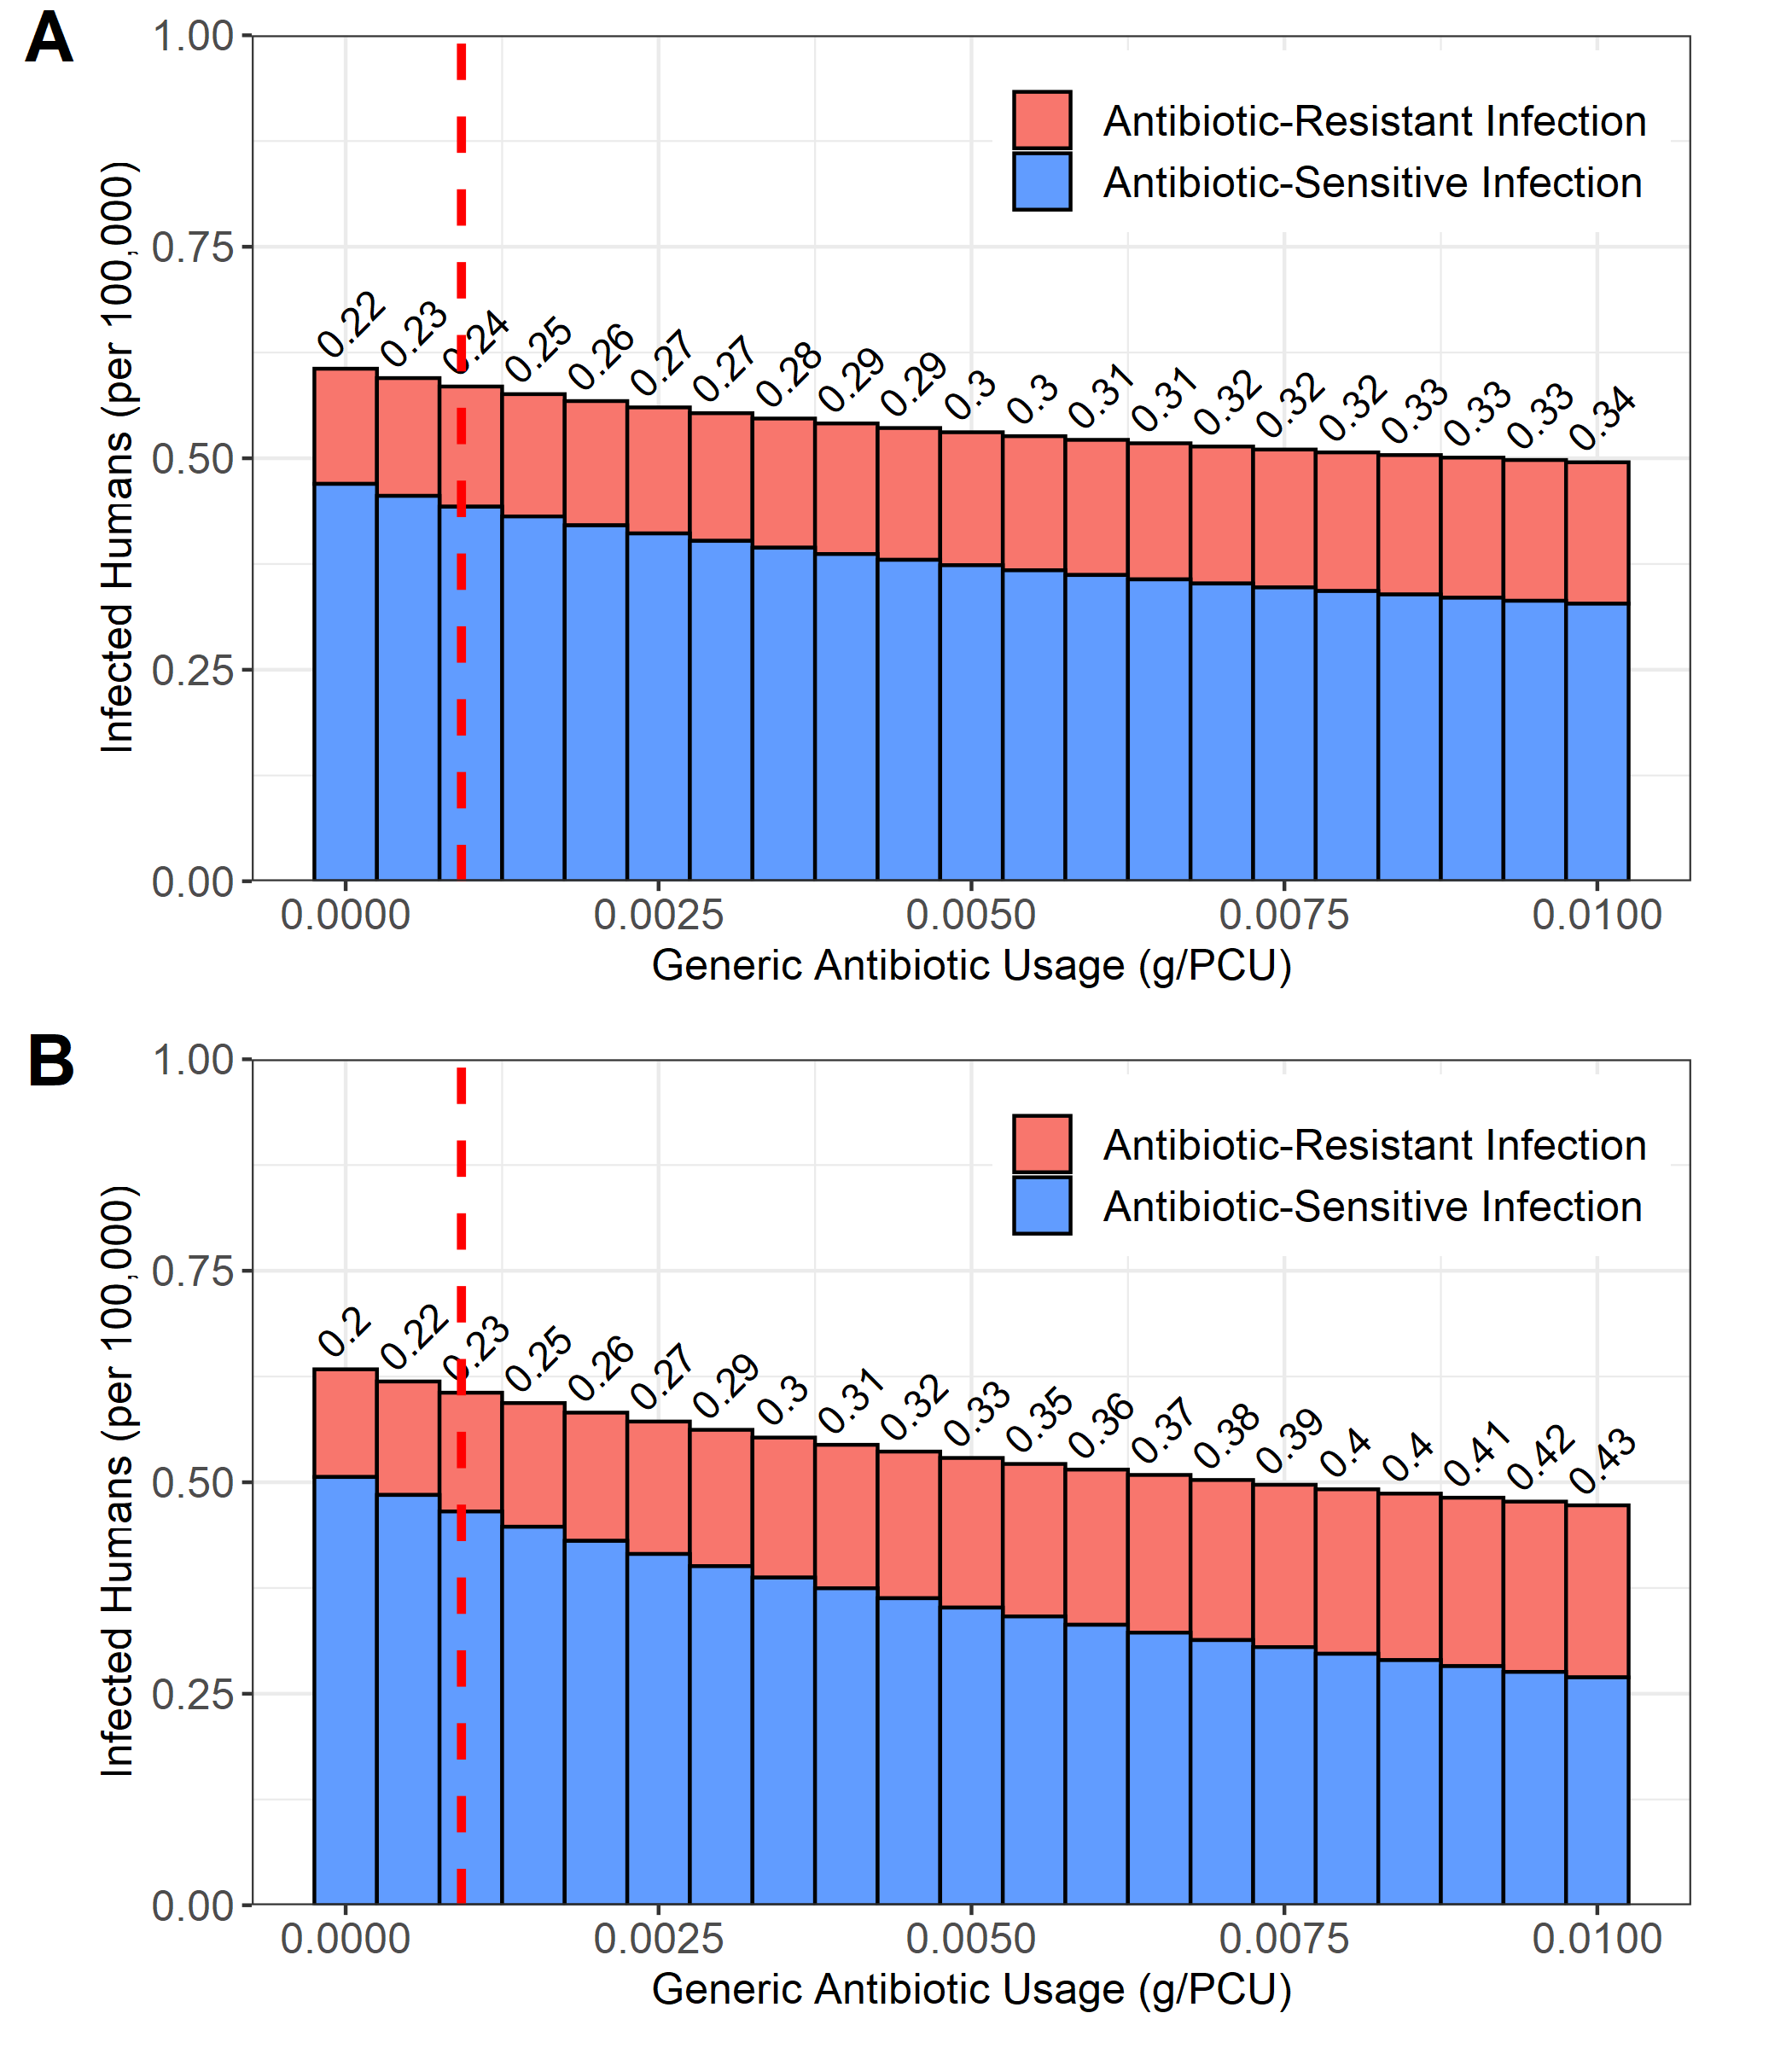

**Figure S5. Impact of alterations in livestock antibiotic usage on the daily incidence of salmonellosis and the proportion of resistant human infection for a model fitted to data with no import pressure (ψ = 1) and a model with homogenous import (ψ = 0.656).** The dotted red line denotes the baseline livestock ampicillin antibiotic usage. Numbers above the bars denote proportion of resistant human salmonellosis.

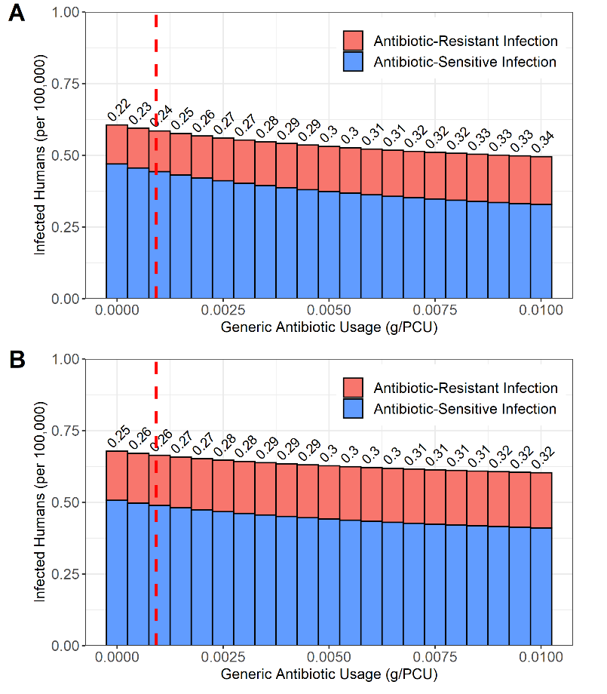

**Figure S6. Impact of alterations in livestock antibiotic usage on the daily incidence of salmonellosis and the proportion of resistant human infection for the homogenous model fitted to data with baseline levels (general livestock products) of import pressure (ψ = 0.656) and a pig food product specific import pressure (ψ = 0.4455).** The dotted red line denotes the baseline livestock ampicillin antibiotic usage. Numbers above the bars denote proportion of resistant human salmonellosis.

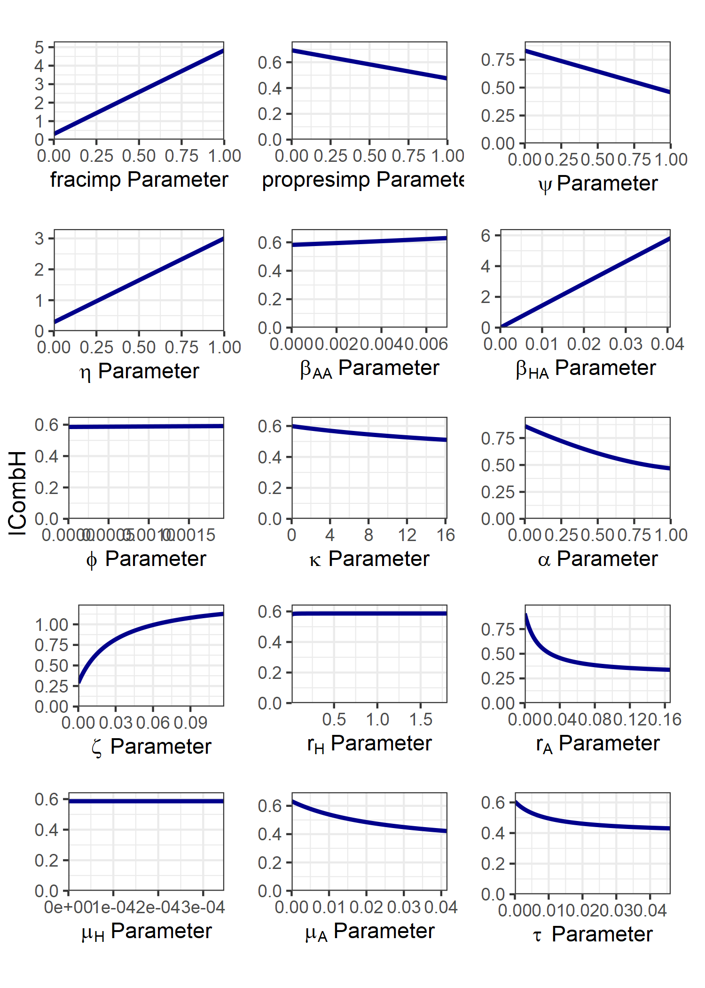

**Figure S7. Impact of varying each model parameter individually on the daily incidence of human salmonellosis for the homogenous import model.** The explored parameter range for each parameter was bounded at 0, to an order of magnitude above the parameterised model value. An exception was for *rH*, with *rH* ∈ [0.01, 0.55-1] to prevent the large relative changes in daily incidence at *rH* = 0 obscuring presented results. For fitted parameters this was taken as an order of magnitude above the mean fitted parameter value across all four case studies.

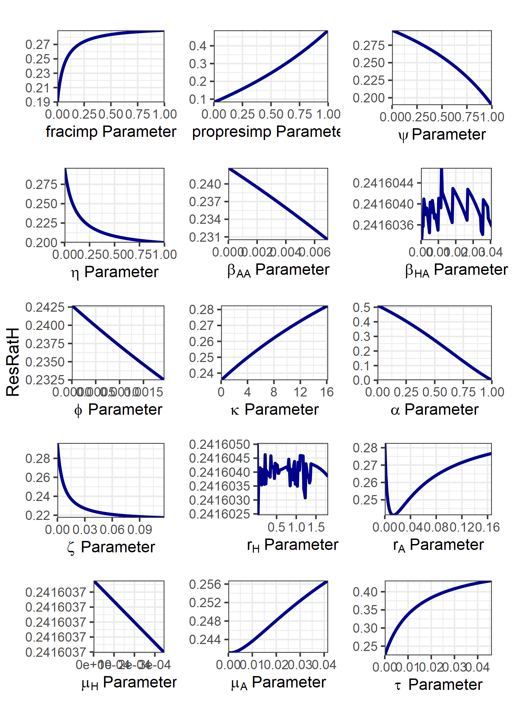

**Figure S8. Impact of varying each model parameter individually on the proportion of ampicillin-resistant human salmonellosis for the homogenous import model.** The explored parameter range for each parameter was bounded at 0, to an order of magnitude above the parameterised model value. An exception was for *rH*, with *rH* ∈ [0.01, 0.55-1] to prevent the large relative changes in daily incidence at *rH* = 0 obscuring presented results. For fitted parameters this was taken as an order of magnitude above the mean fitted parameter value across all four case studies. Note that rA displays a non-monotonic relationship with the outcome measure.

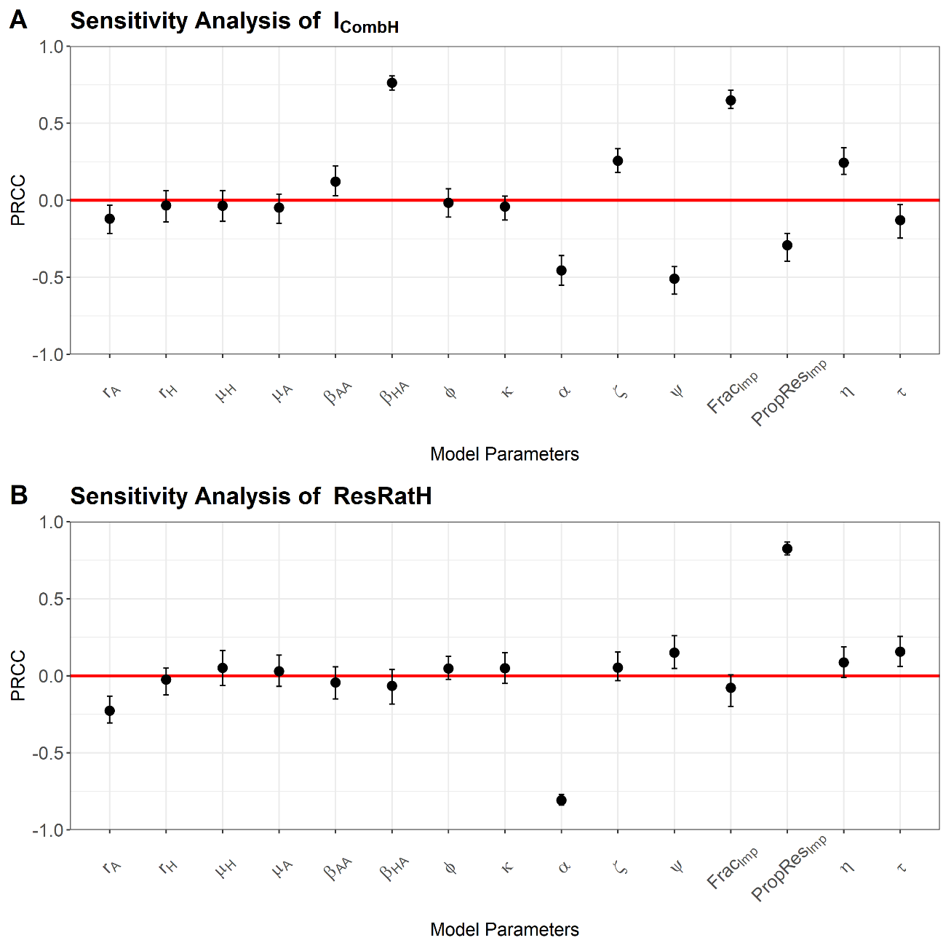

**Figure S9. Latin hypercube sampling partial rank correlation coefficient (LHS-PRCC) sensitivity analysis for the homogenous import model. A) Daily incidence of human salmonellosis. B) Proportion of human ampicillin resistant salmonellosis.** Note that 95% confidence intervals for each correlation coefficient was generated through generating n = 100 bootstrap replicates.

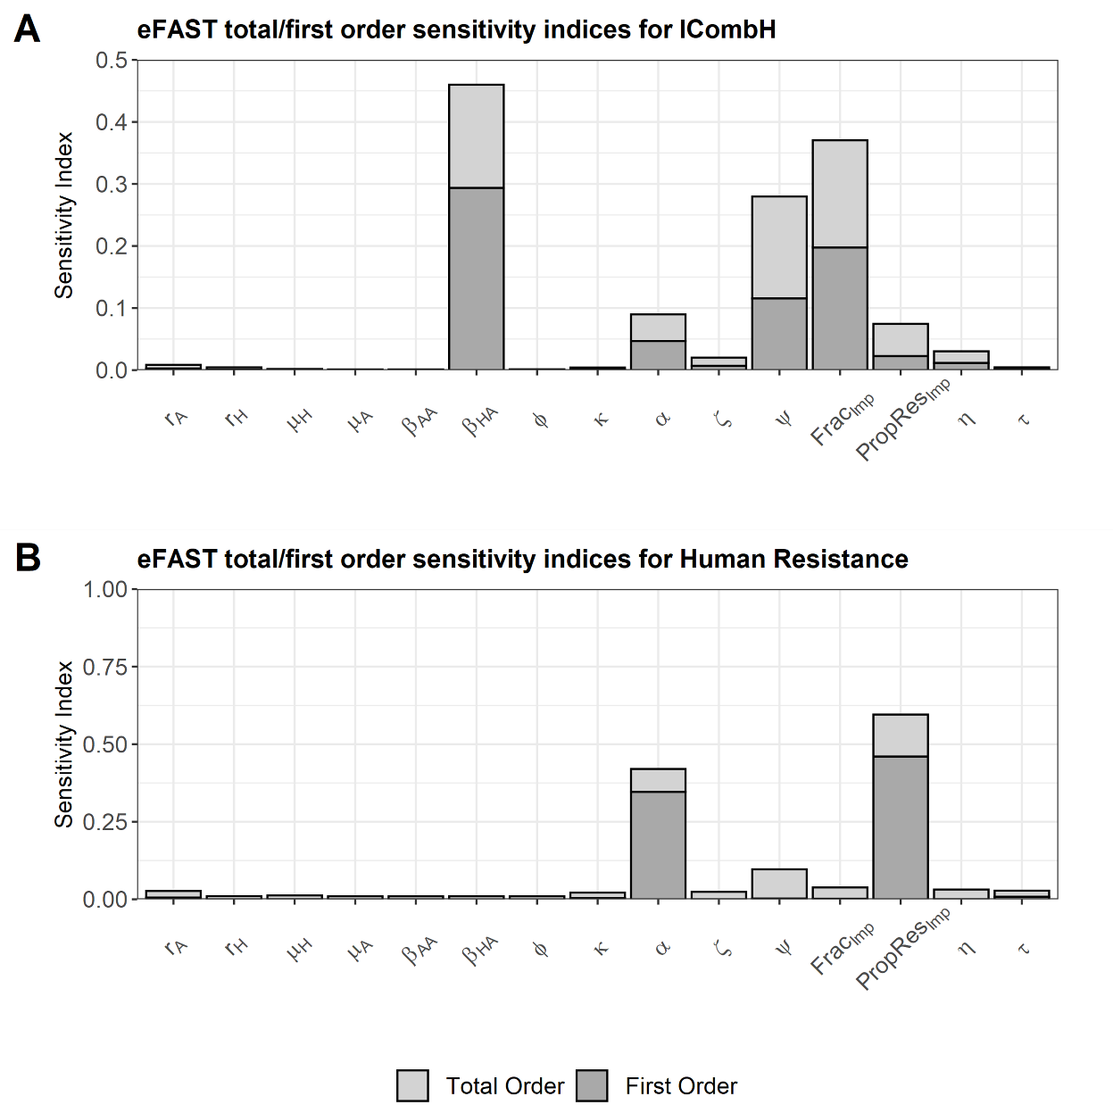

**Figure S9. Extended Fourier amplitude sensitivity analysis (eFAST) sensitivity analysis for the homogenous import model. A) Daily incidence of human salmonellosis. B) Proportion of human ampicillin resistant salmonellosis.** The remaining proportion of the total order effects after accounting for first order effects in the eFAST can be considered the second order effects for each explored model parameter.

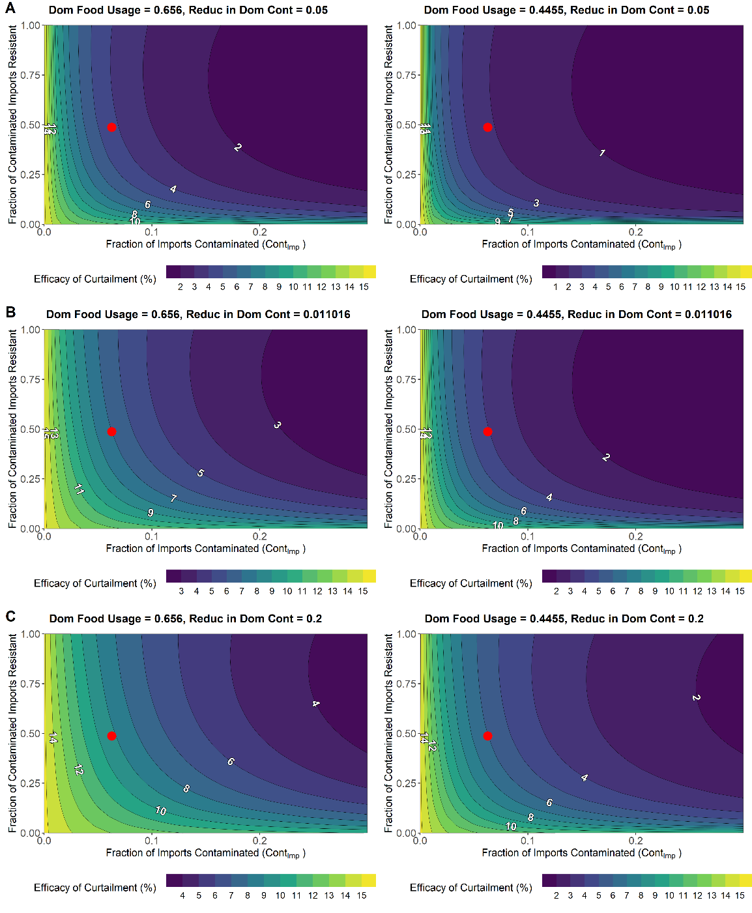

**Figure S10. Impact of altering FracImp and PropResImp import parameters on the efficacy of curtailment for the relative reduction in prevalence of Salmonella spp. from domestic livestock to carcasses. We explore two alternative scenarios relative to the baseline. A) Strong reductions to the level of contamination found in domestic livestock carcasses (η = 0.05). B) Baseline reductions to the level of contamination found in domestic livestock carcasses (η = 0.011). C) Weaker reductions to the level of contamination found in domestic livestock carcasses (η = 0.20).** For each value of η we explore a general livestock import case study (ψ = 0.656) and a scenario of import based on swine food products (ψ = 0.4455**).** Red dot represents the baseline parameterisation for FracImp and PropResImp parameters from ECDC data (FracImp = 0.0628; PropResImp = 0.487).

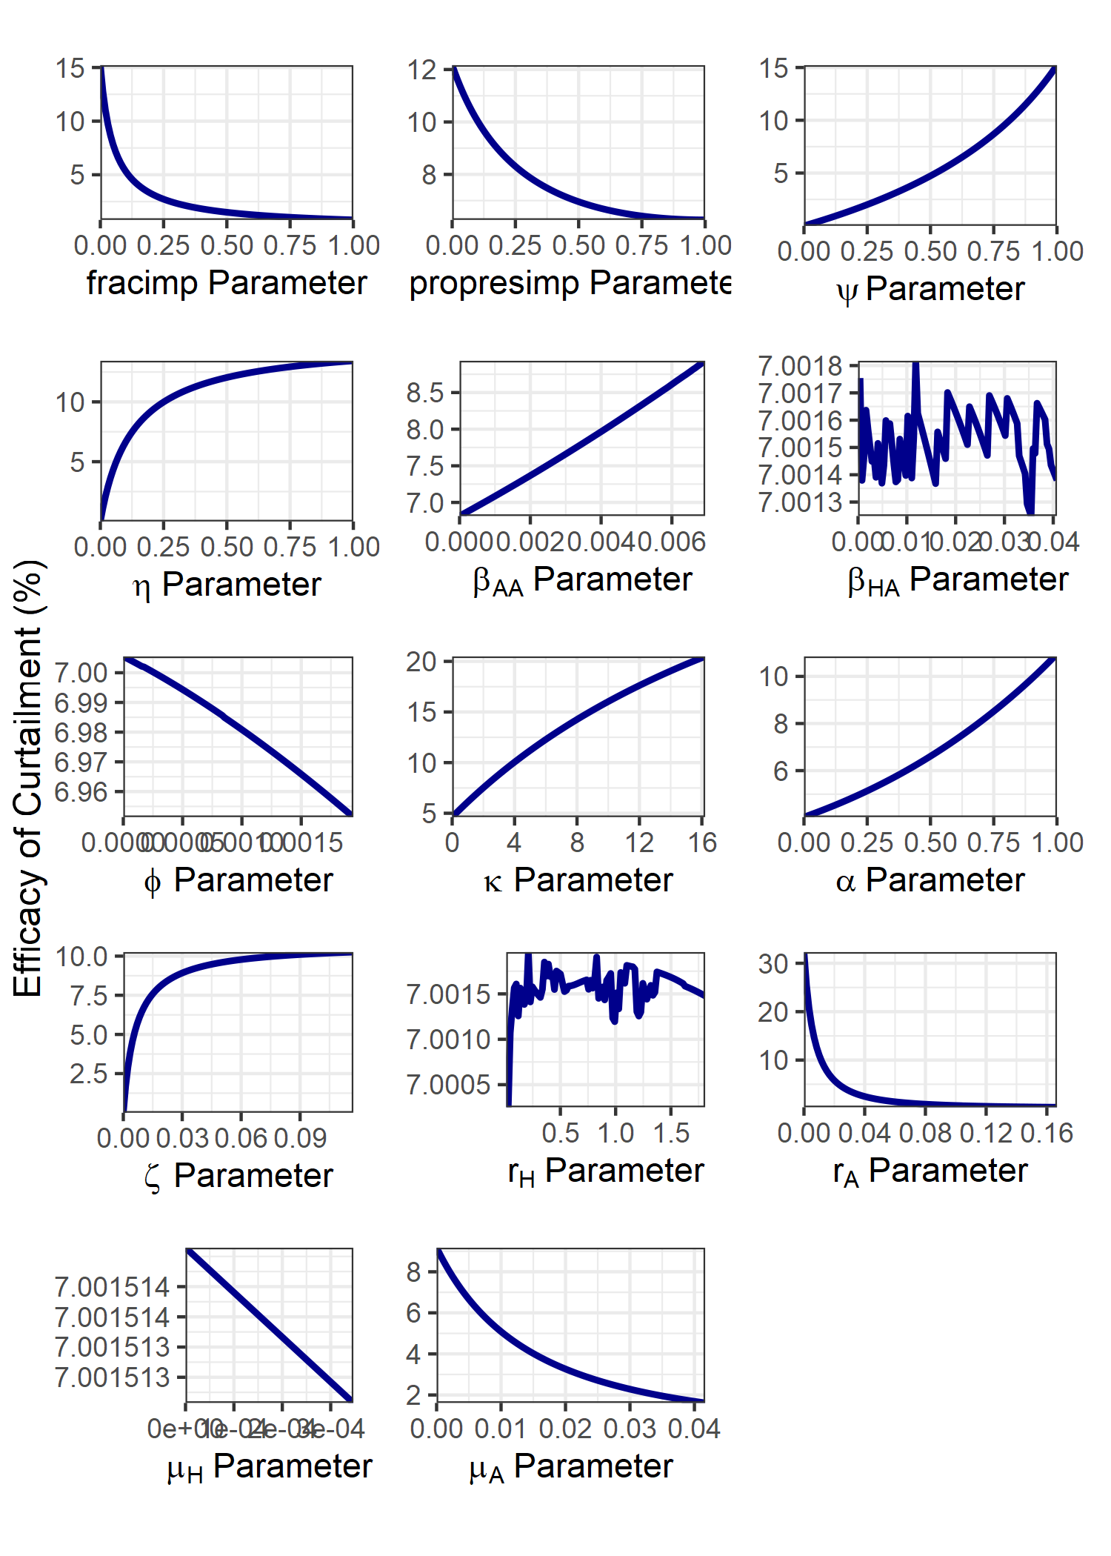

**Figure S11. Impact of varying each model parameter individually on the efficacy of curtailment outcome measure for the homogenous import model.** The explored parameter range for each parameter was bounded at 0, to an order of magnitude above the parameterised model value. An exception was for *rH*, with *rH* ∈ [0.01, 0.55-1] to prevent the large relative changes in daily incidence at *rH* = 0 obscuring presented results. For fitted parameters this was taken as an order of magnitude above the mean fitted parameter value across all four case studies. Note that rA displays a non-monotonic relationship with the outcome measure.

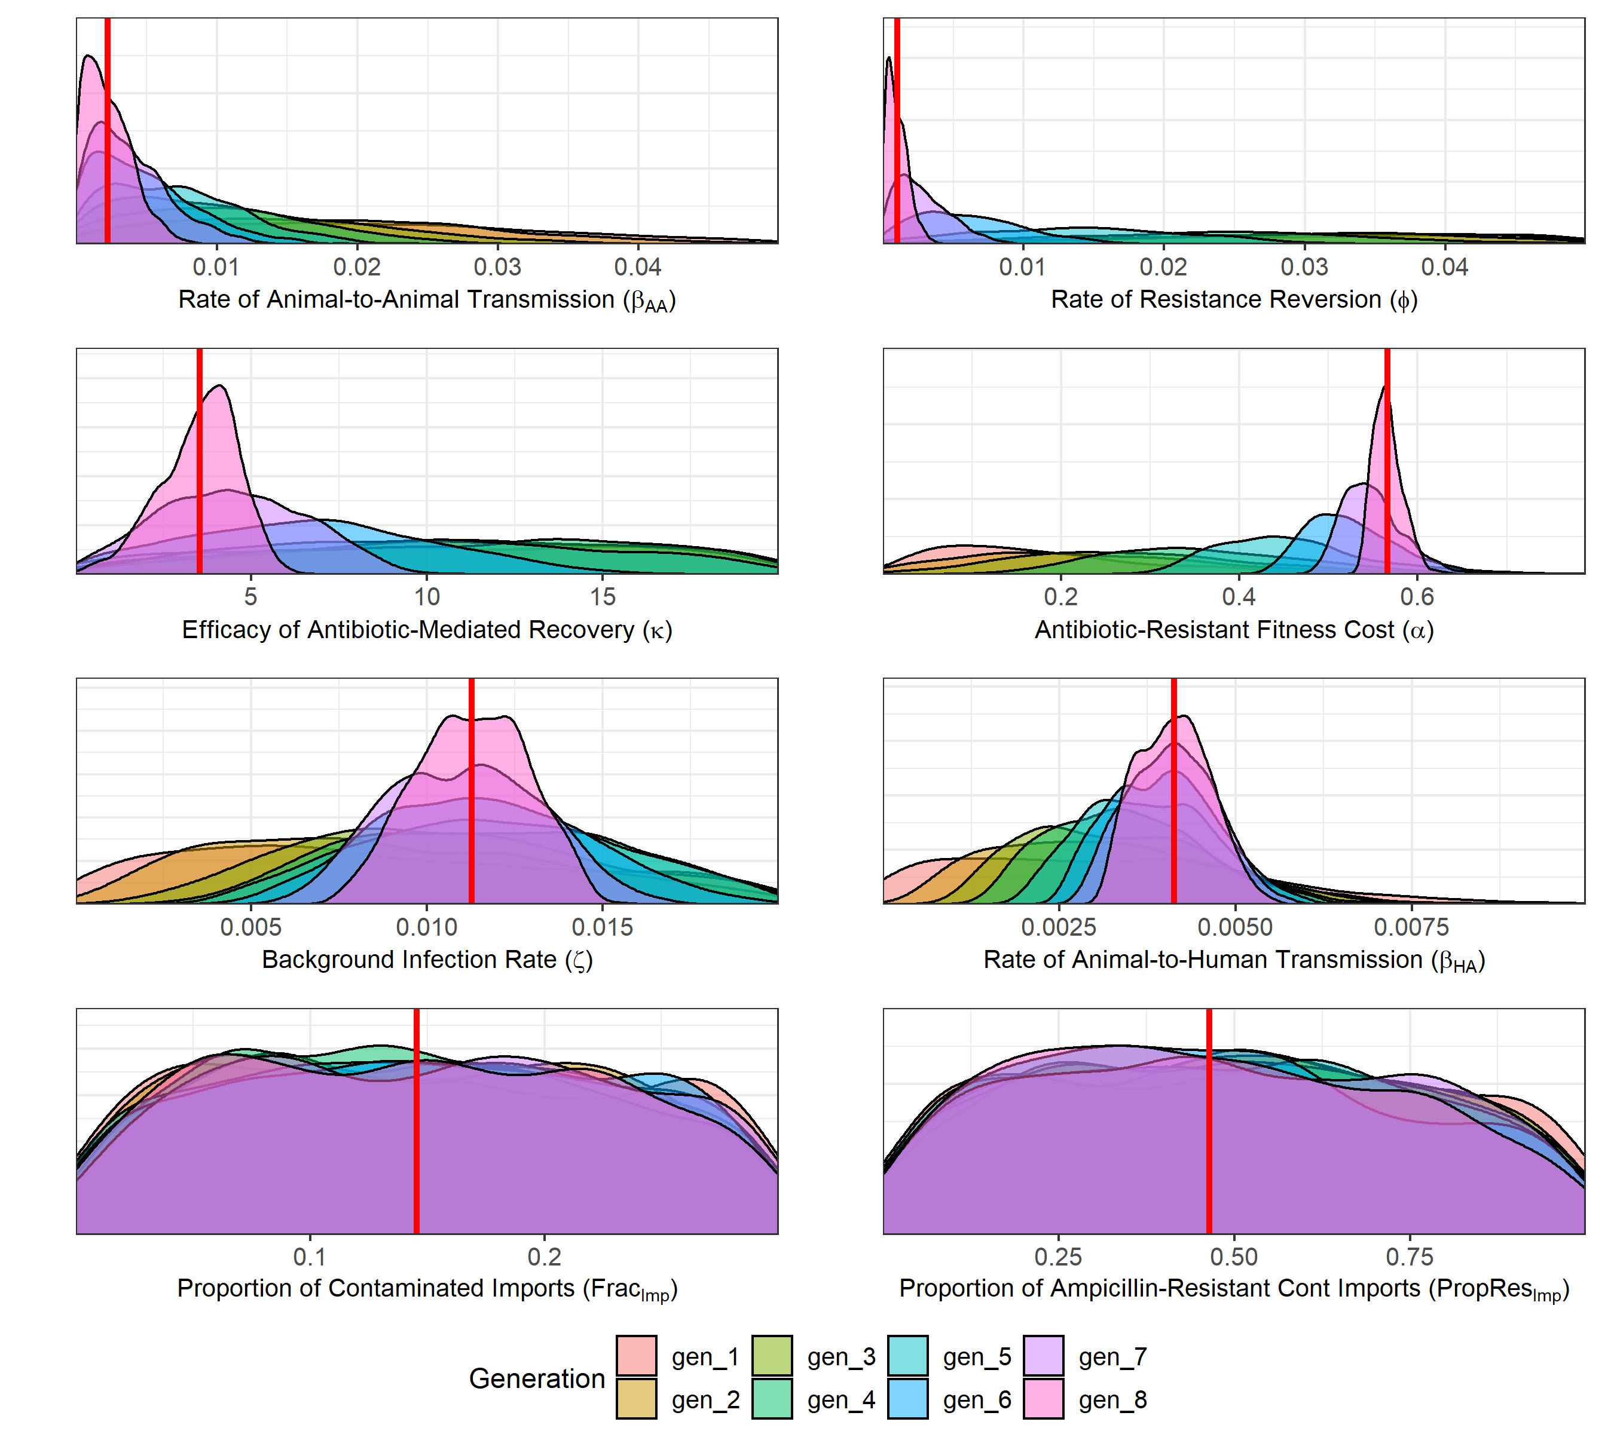

**Figure S12. Estimated posterior distributions for the rate of animal-to-animal transmission (βAA), efficacy of antibiotic-mediated recovery (κ), rate of antibiotic-resistant to antibiotic-sensitive reversion (φ), transmission-related fitness costs of resistance (α), background rate of transmission to animal populations (ζ), the rate of animal-to-human transmission (βHA), the proportion of imported food products contaminated with Salmonella spp. (FracImp) and the proportion of contaminated food products resistant to ampicillin (PropResImp).** The estimated posterior distribution for each generation is highlighted by fill colours. Red line represents the mean from the 8th generation for each parameter.

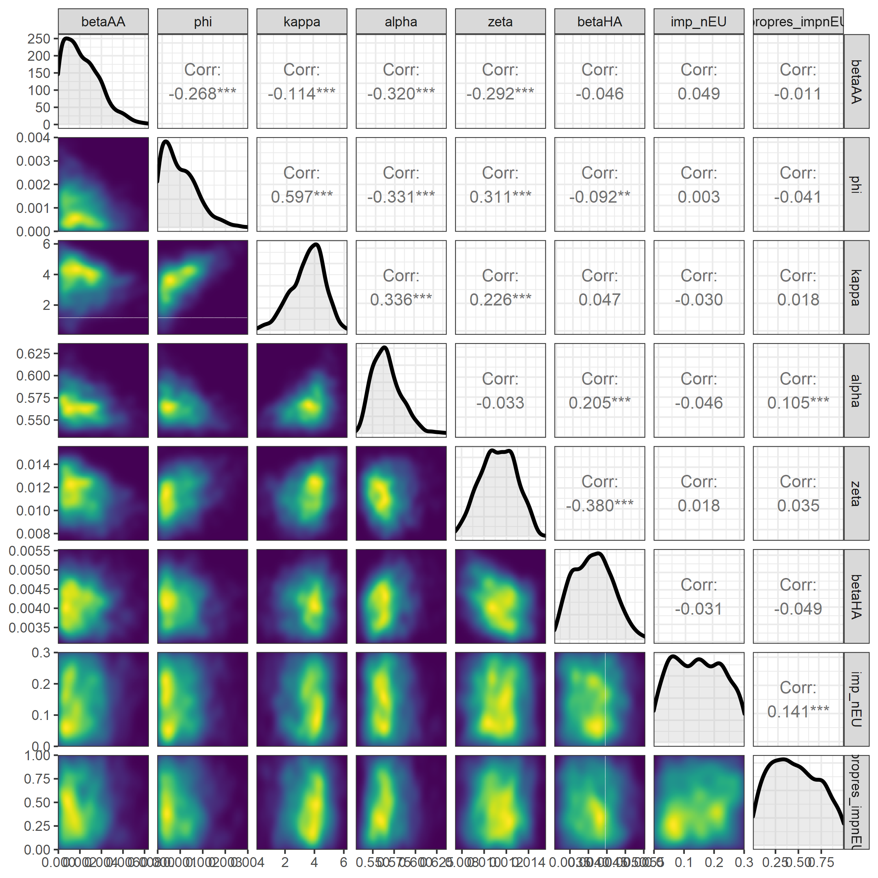

**Figure S13. Pairs plot for the approximated posterior distribution and the correlation coefficients for the homogenous import model fit.** The diagonals show the the approximated univariate posterior distribution. Kernel density estimation was used to identify the parameter space where a greater concentration of particles were accepted for the final tenth ABC-SMC generation (lighter colouring).

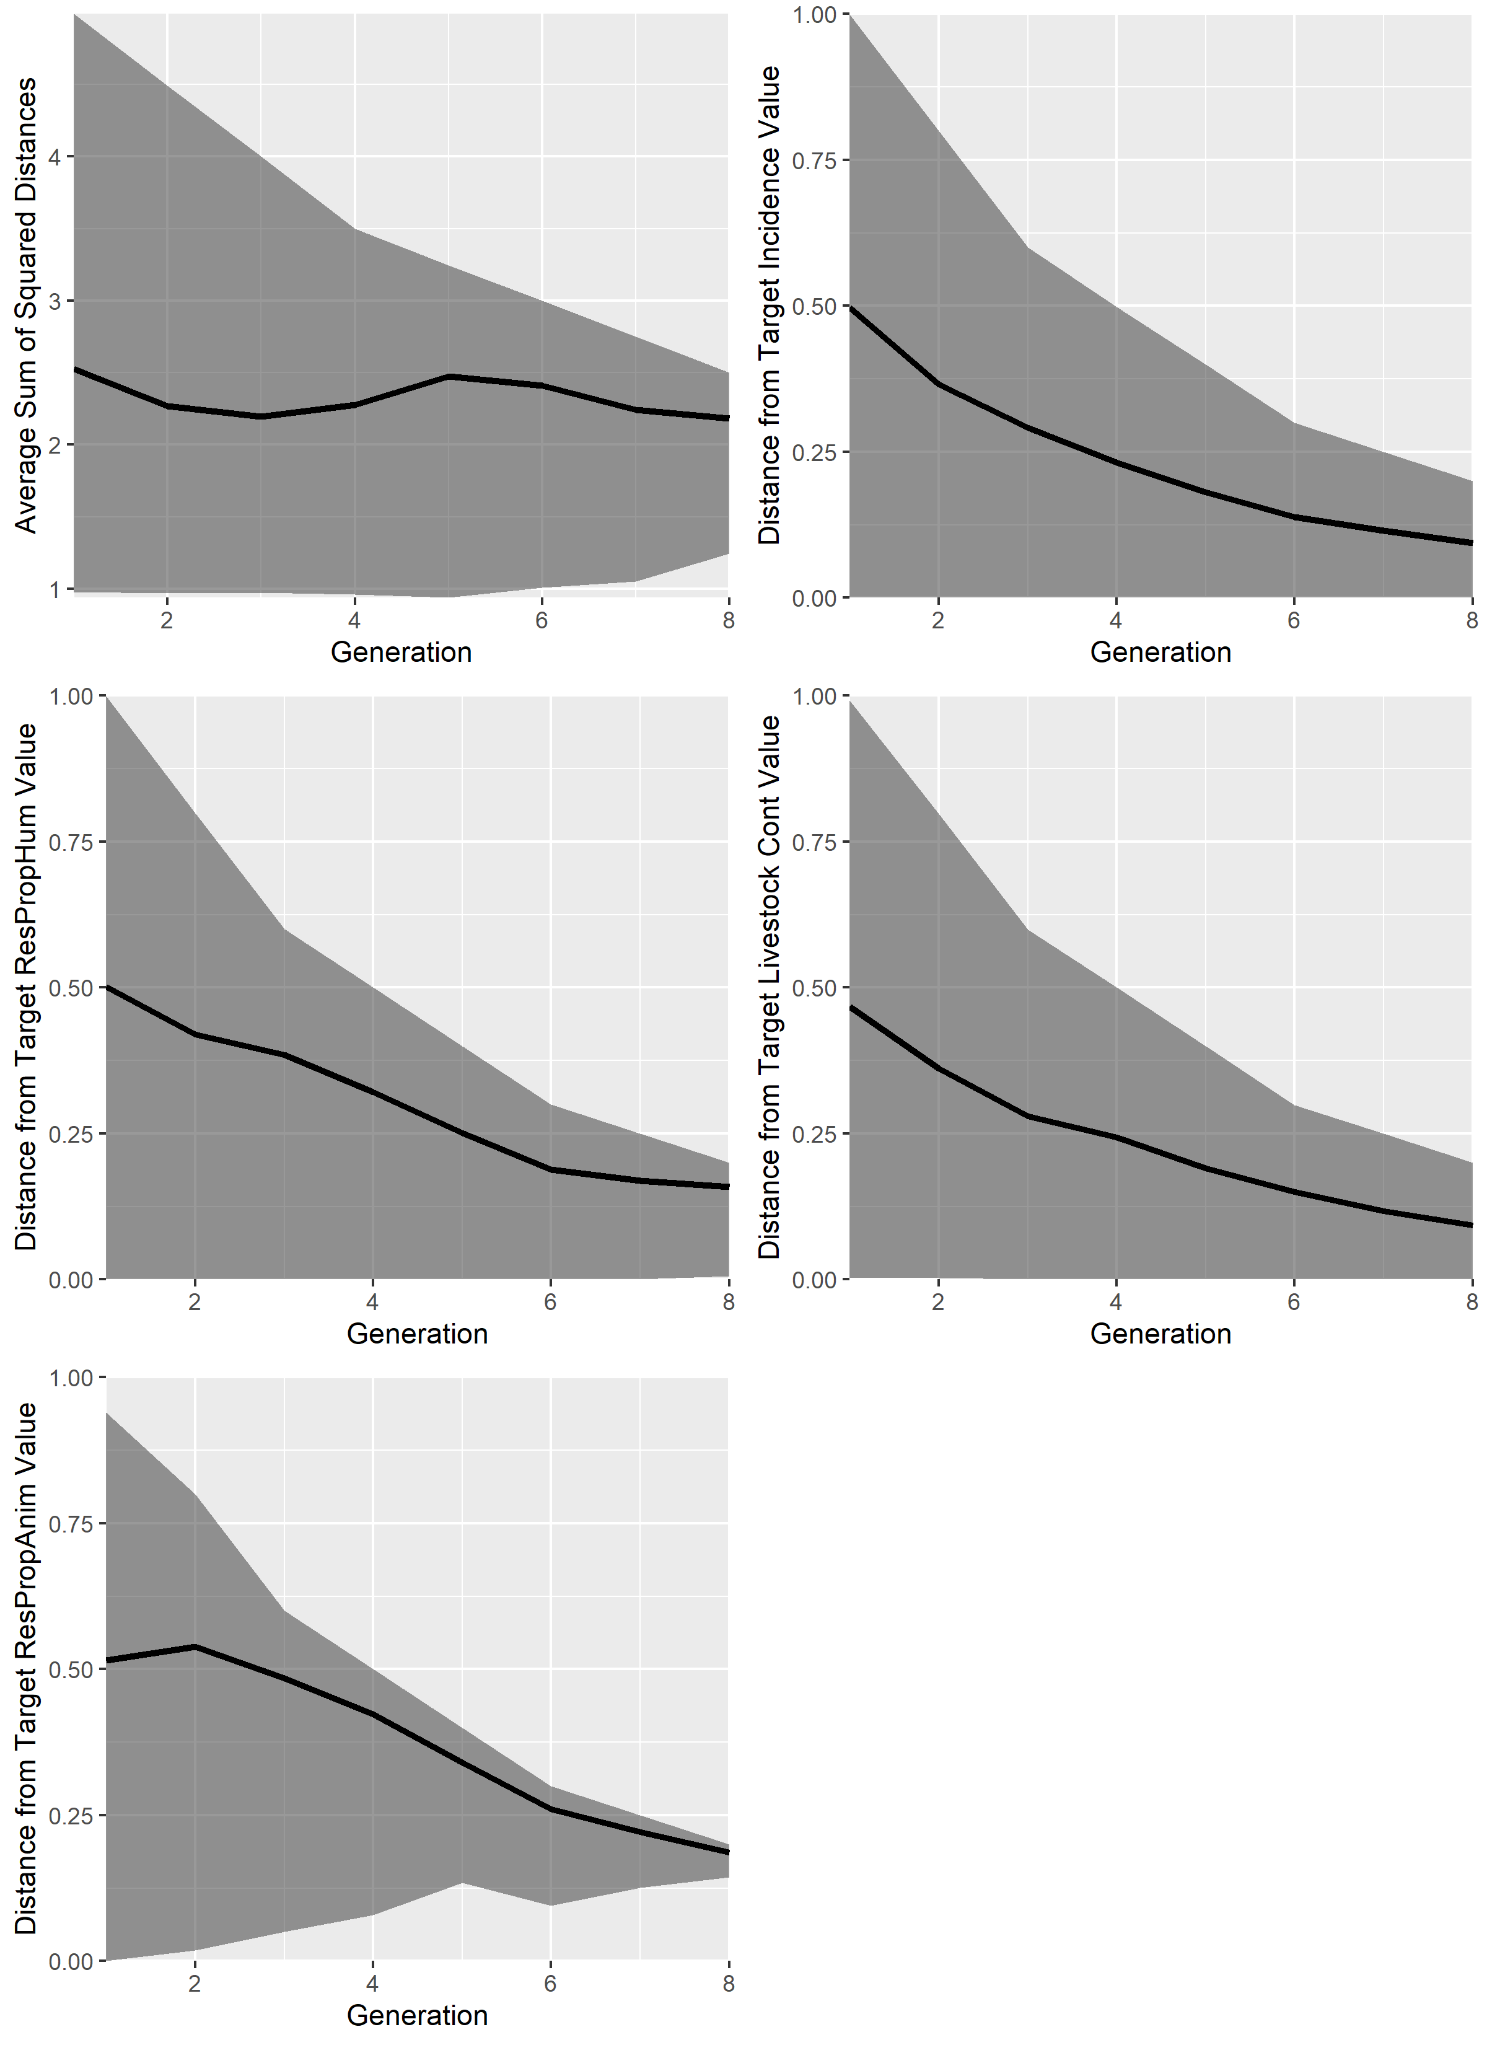

**Figure S14. Diagnostic plots showing the average sum of squared distance for each generation of the ABC-SMC model fit for the heterogenous model.** Diagnostic plots were plotted for the average sum of square distances for the resistance/usage model fit, distance from the target incidence of human salmonellosis, distance from the target proportion of resistant human salmonellosis, distance from the target livestock contamination (ISA + IRA * η) and the distance from the target proportion of antibiotic-resistant human salmonellosis.

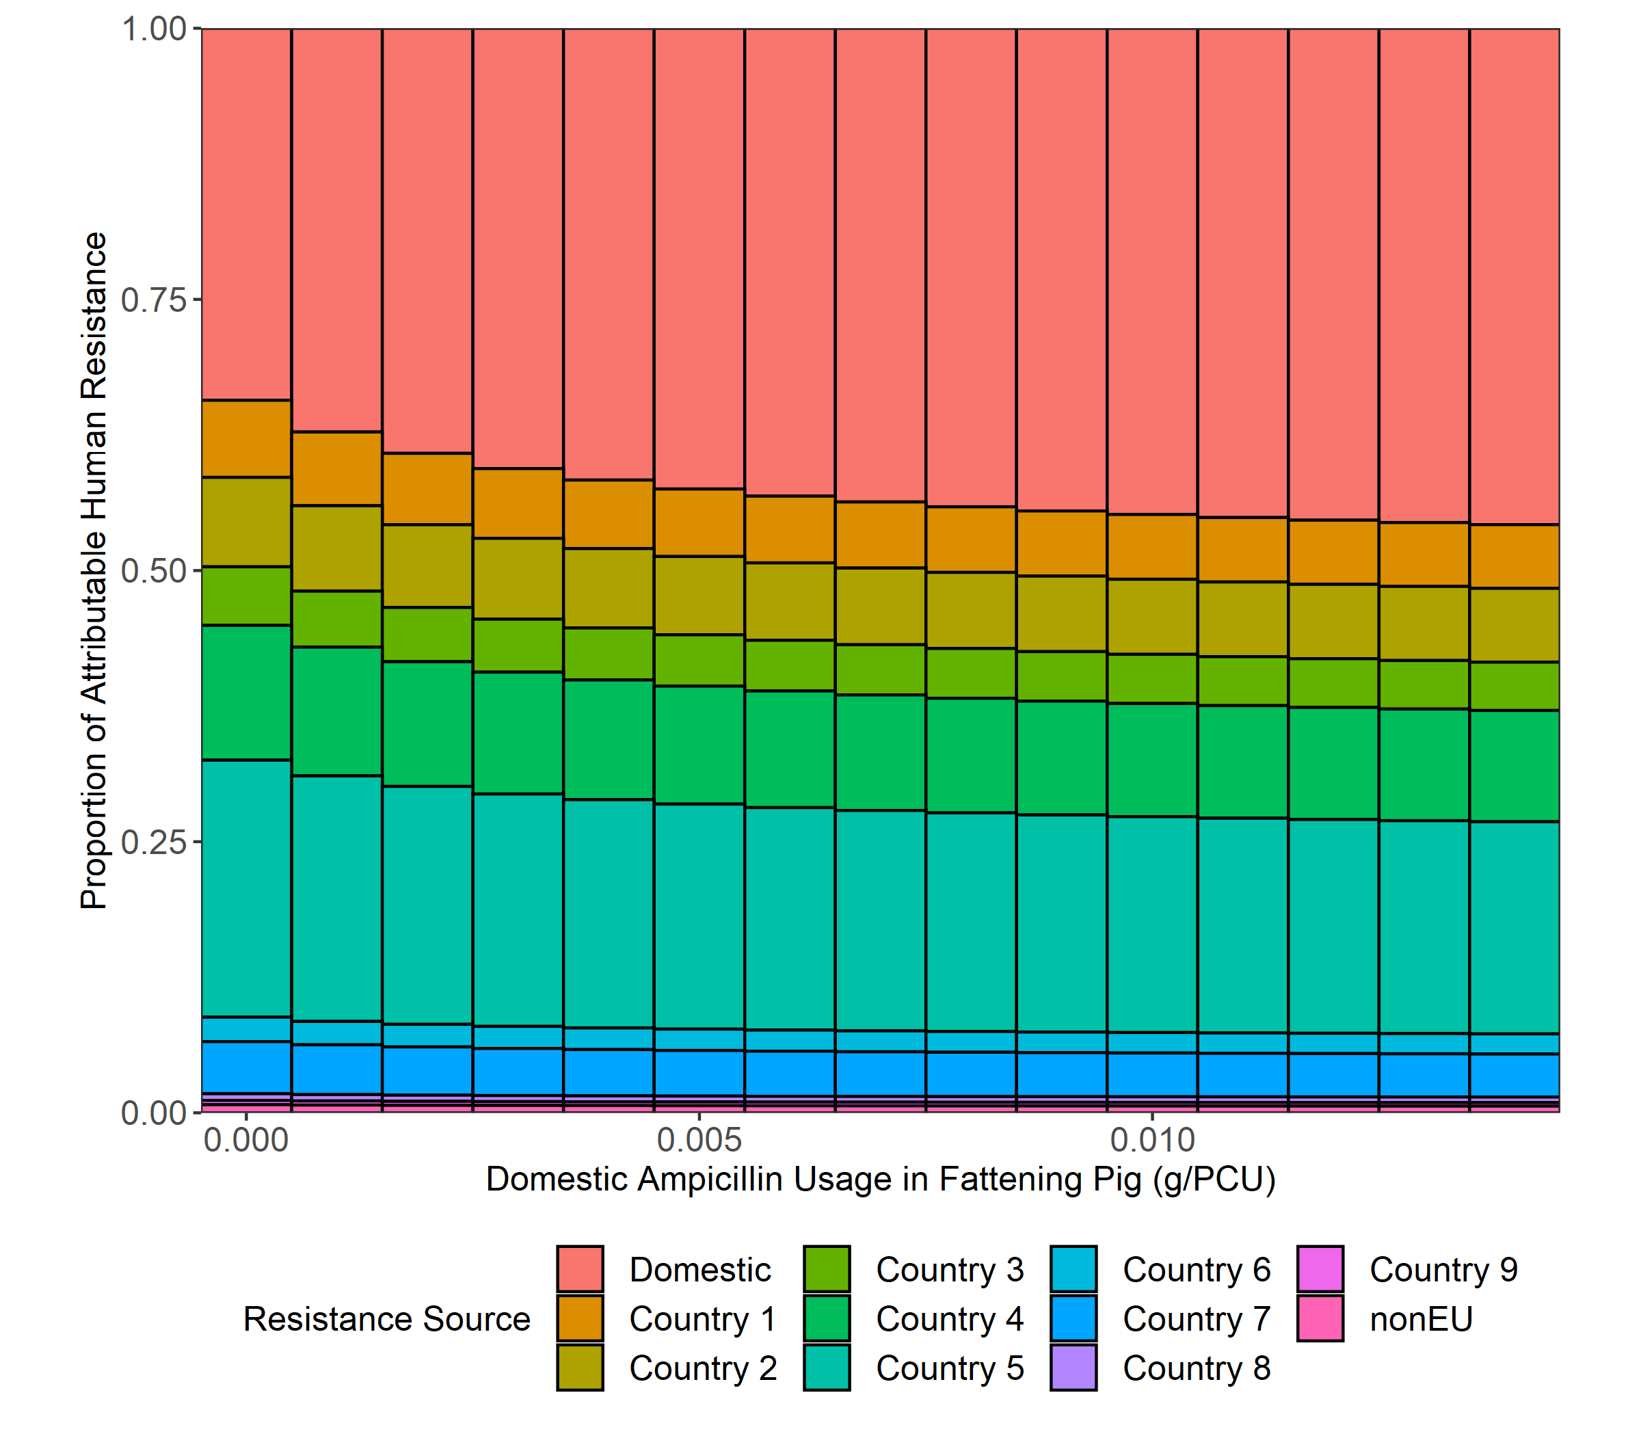

**Figure S15. Impact of alterations in livestock antibiotic usage on the normalised proportion of resistant human infection for the heterogenous model attributable to domestic and non-domestic sources.** Normalisation was performed by dividing the proportion of ampicillin-resistant salmonellosis attributable to each country by the sum.

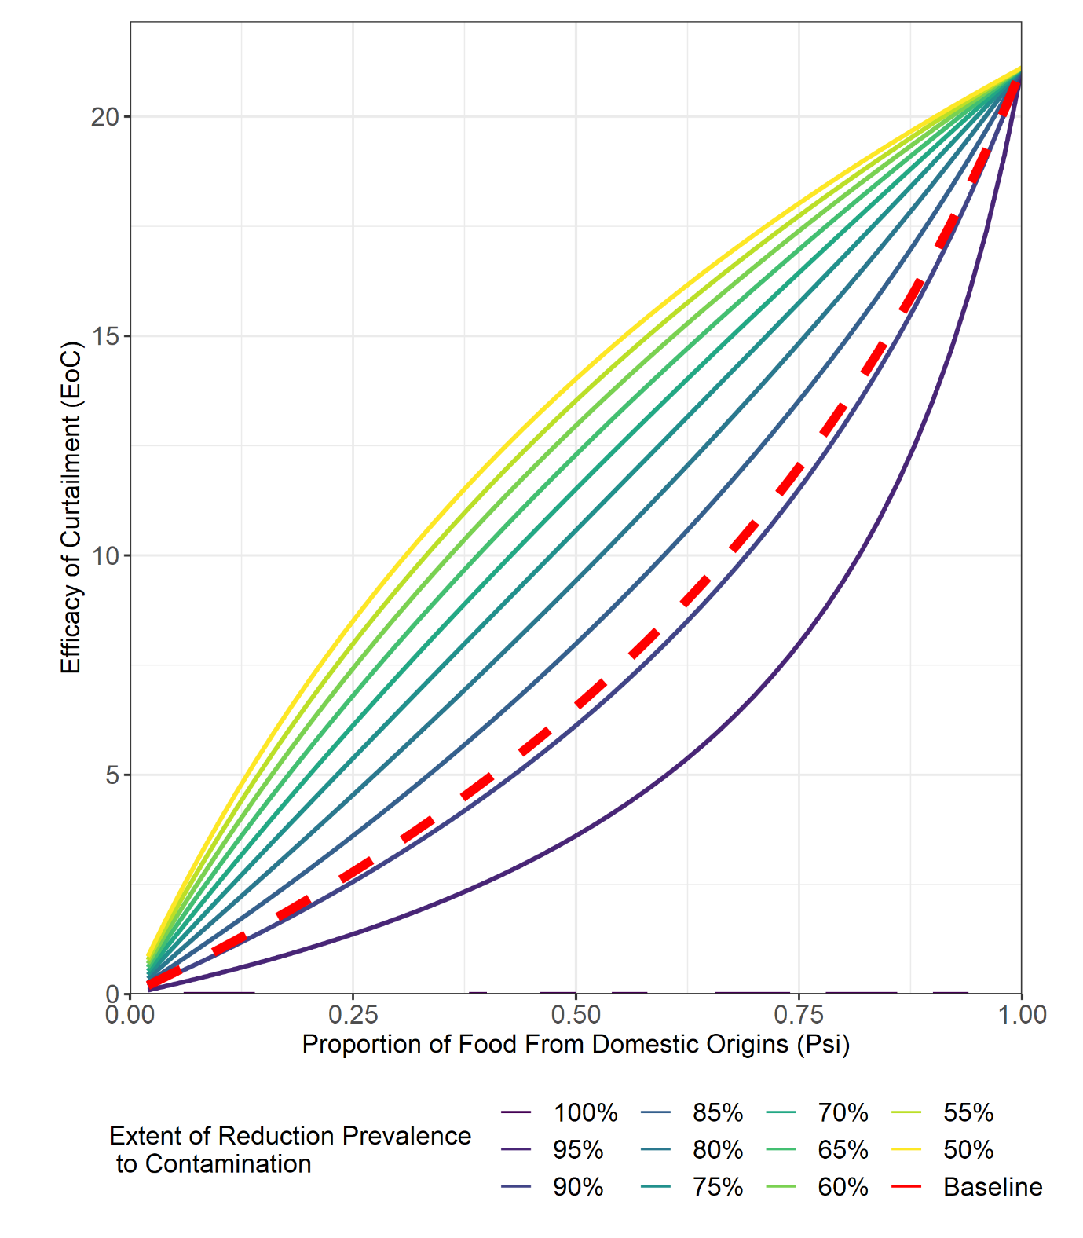

**Figure S16. Relationship between the proportion of UK food products (ψ) and the efficacy of curtailment (EoC) under different average parameterisation for the η parameter.** Baseline relationship between EoC/ψ is denoted by the red and dotted line.

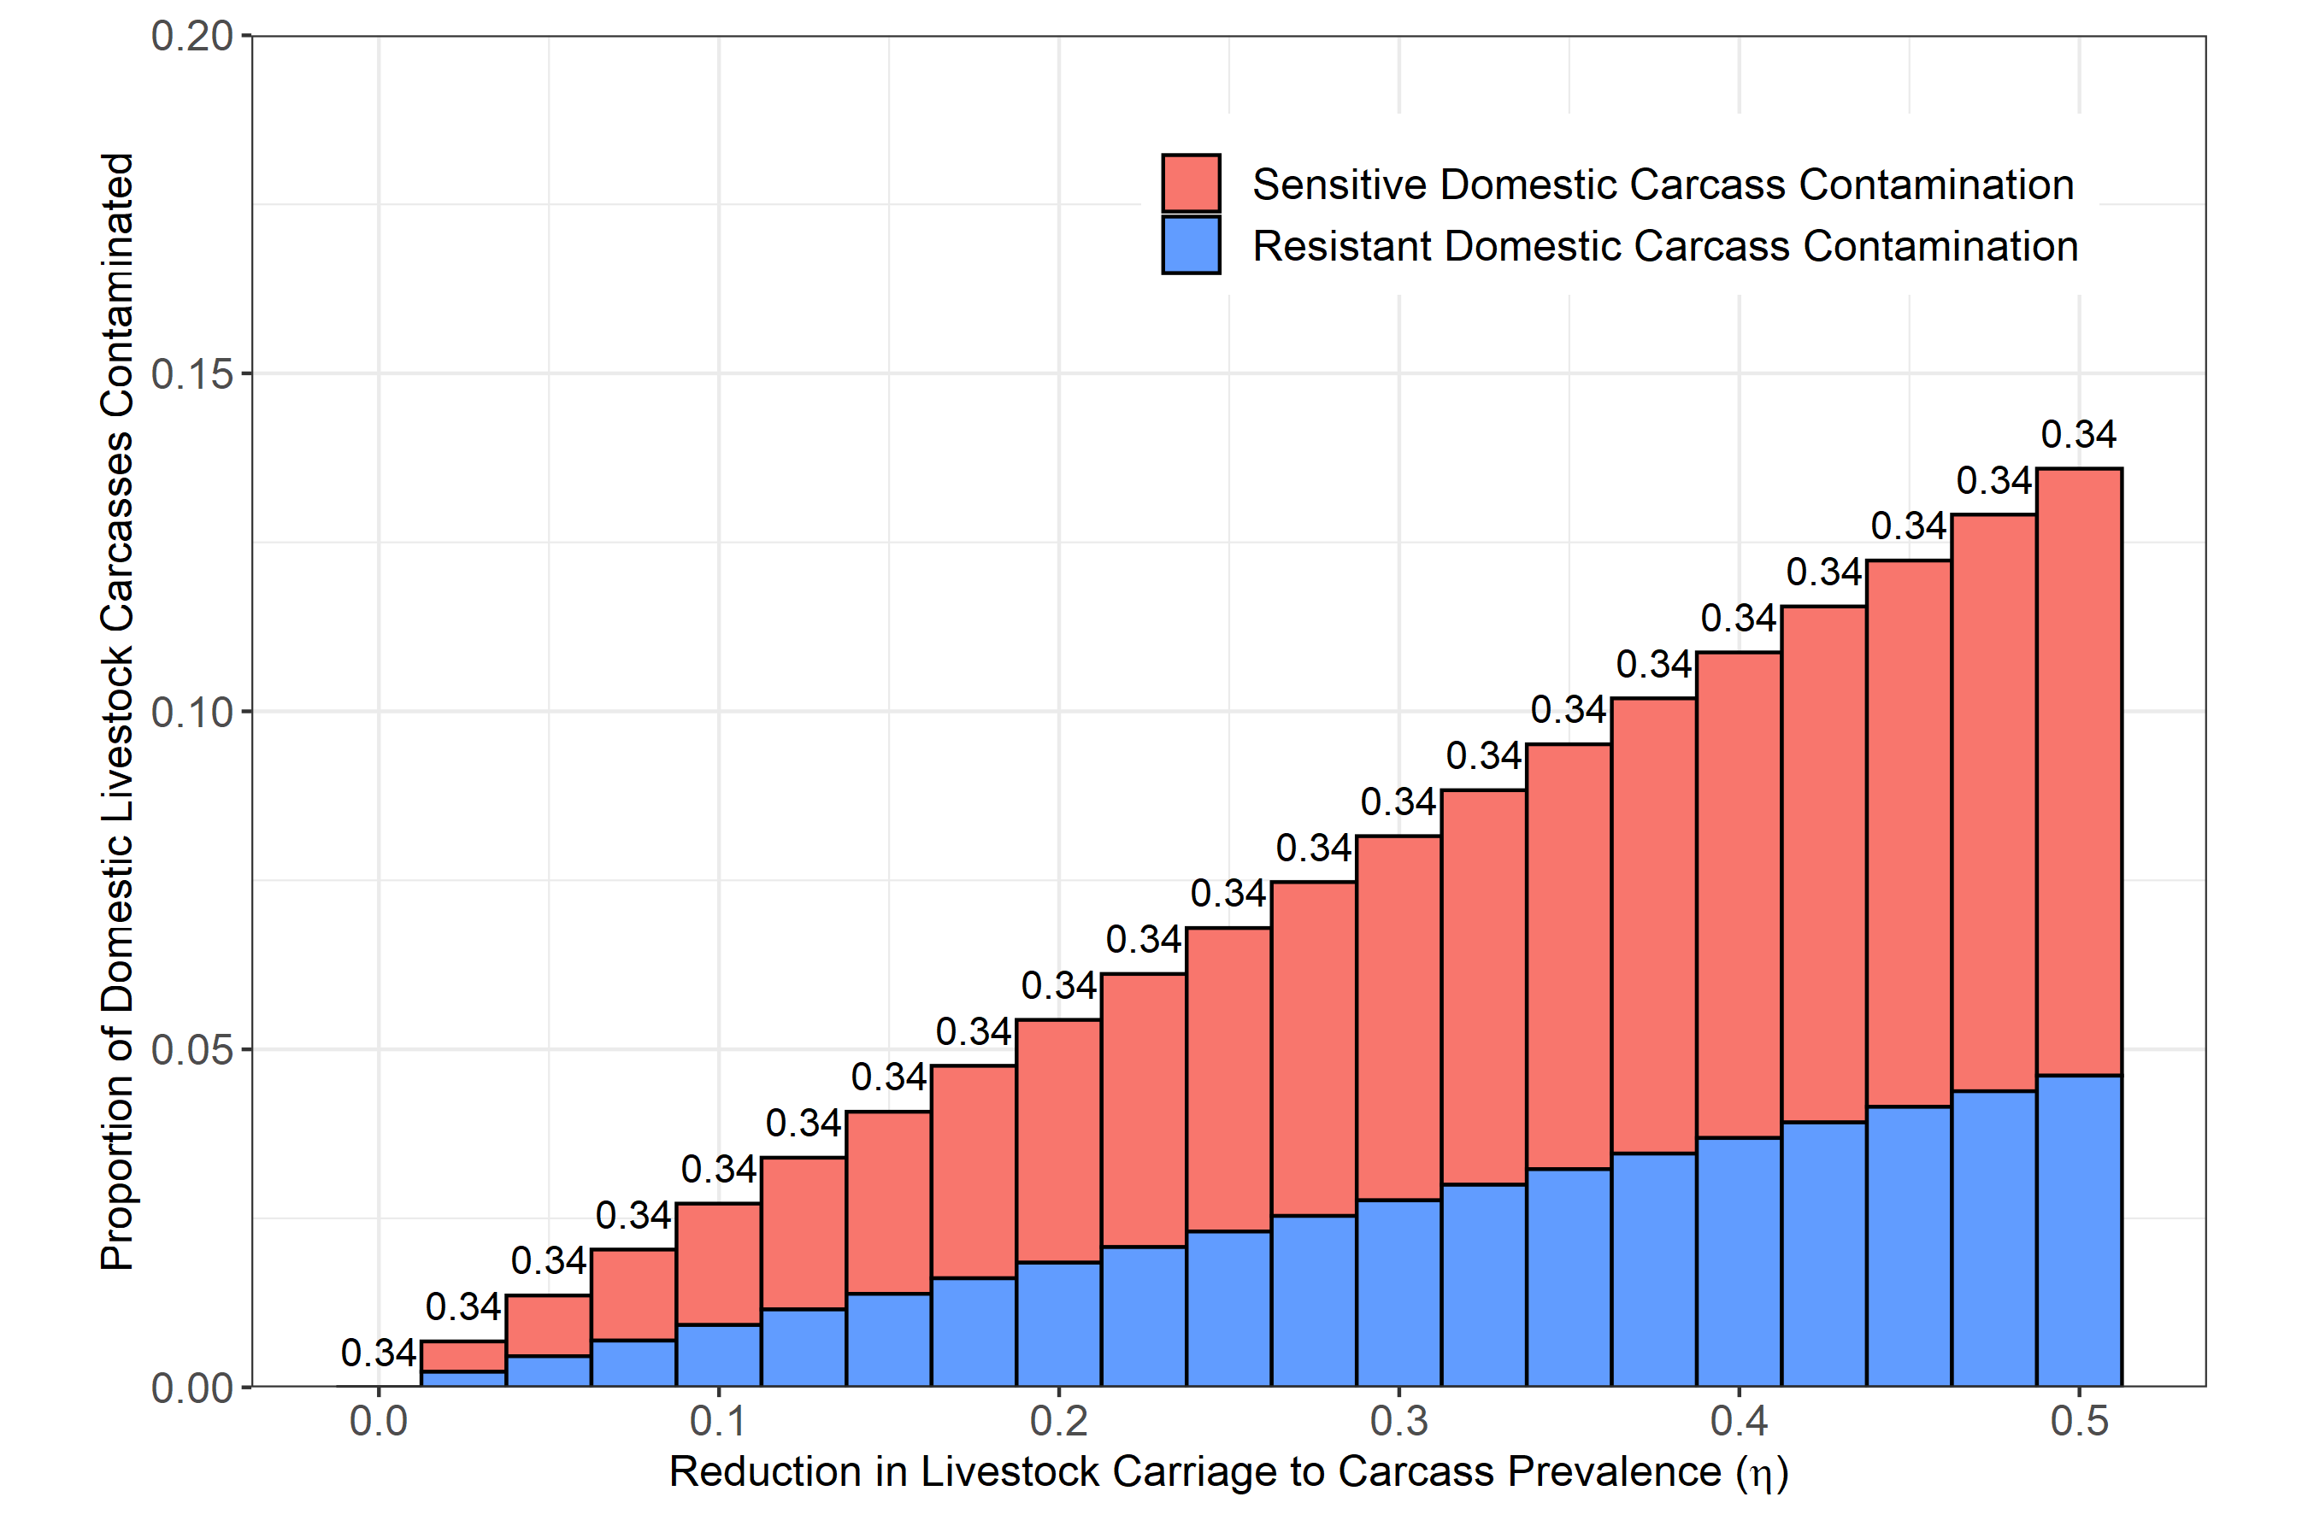

**Figure S17. Relationship between the relative reduction in prevalence from domestic livestock carriage to carcass contamination (η) on both the proportion of domestic livestock carcasses contaminated with Salmonella spp. and the proportion of the ampicillin-resistant domestic carcasses.** Numbers above the bars denote proportion of resistant human salmonellosis.

**REFERENCES**

1. European Medicines Agency ESoVAC. Sales of veterinary antimicrobial agents in 31 European countries in 2015. European Medicines Agency; 2017.

2. European Medicines Agency ESoVAC. Sales of veterinary antimicrobial agents in 31 European countries in 2016. European Medicines Agency; 2018.

3. European Medicines Agency ESoVAC. Sales of veterinary antimicrobial agents in 31 European countries in 2017. European Medicines Agency; 2019.

4. European Medicines Agency ESoVAC. Sales of veterinary antimicrobial agents in 31 European countries in 2018. European Medicines Agency; 2020.

5. Authority EFS, Prevention ECfD, Control. The European Union summary report on antimicrobial resistance in zoonotic and indicator bacteria from humans, animals and food in 2015. EFSA Journal. 2017;15(2):e04694.

6. Authority EFS, Prevention ECfD, Control. The European Union summary report on antimicrobial resistance in zoonotic and indicator bacteria from humans, animals and food in 2016. EFSA Journal. 2018;16(2):e05182.

7. Authority EFS, Prevention ECfD, Control. The European Union summary report on antimicrobial resistance in zoonotic and indicator bacteria from humans, animals and food in 2017. EFSA Journal. 2019;17(2):e05598.

8. Authority EFS, Prevention ECfD, Control. The European Union Summary Report on Antimicrobial Resistance in zoonotic and indicator bacteria from humans, animals and food in 2017/2018. EFSA Journal. 2020;18(3):e06007.

9. Department for Environment FaRA. Agriculture in the United Kingdom 2019. Department for Environment, Food and Rural Affairs; 2020 25/06/20.

10. Authority EFS, Prevention ECfD, Control. The European Union one health 2018 zoonoses report. EFSA Journal. 2019;17(12):e05926.

11. Authority EFS, Prevention ECfD, Control. The European Union summary report on trends and sources of zoonoses, zoonotic agents and food‐borne outbreaks in 2015. EFSA Journal. 2016;14(12):e04634.

12. Authority EFS. The European Union summary report on trends and sources of zoonoses, zoonotic agents and food‐borne outbreaks in 2016. EFSA journal. 2017;15(12).

13. Authority EFS, Prevention ECfD, Control. The European Union summary report on trends and sources of zoonoses, zoonotic agents and food‐borne outbreaks in 2017. EFSa Journal. 2018;16(12):e05500.

14. Cassini A, Colzani E, Pini A, Mangen M-JJ, Plass D, McDonald SA, et al. Impact of infectious diseases on population health using incidence-based disability-adjusted life years (DALYs): results from the Burden of Communicable Diseases in Europe study, European Union and European Economic Area countries, 2009 to 2013. Eurosurveillance. 2018;23(16):17-00454.

15. Nair S, Farzan A, O'Sullivan TL, Friendship RM. Time course of Salmonella shedding and antibody response in naturally infected pigs during grower-finisher stage. Can J Vet Res. 2018;82(2):139-45.

16. Organisation WH. Salmonella (non-typhoidal) Geneva: World Health Organisation; 2018 [Available from: <https://www.who.int/news-room/fact-sheets/detail/salmonella-(non-typhoidal>).

17. Sheridan J, Allen P, Ziegler J, Marinkov M, Suvakov M, Heinz G. Guidelines for slaughtering, meat cutting and further processing: FAO; 1991.

18. Roser M. Life expectancy 2013 [Available from: <https://ourworldindata.org/life-expectancy>.

19. Martelli F, Oastler C, Barker A, Jackson G, Smith R, Davies R. Abattoir-based study of Salmonella prevalence in pigs at slaughter in Great Britain. Epidemiology & Infection. 2021;149.